Om Gupta (Ext)

Datamato  Pune

UCD-UAT Pre-Upgrade

Table of Contents

**1 ] UCD Version5**

**2 ] Dashboard5**

**3 ] Component : 6**

3.1 ] Component tab 6

3.2 ] Template tab6

**4 ] Application7**

4.1 ] Application Tab 7

4.2 ]Template Tab 7

**5 ] Processes 8**

**6 ] Resources 8**

6.1 ] Resource tree 9

6.2 ] Resource Templates9

6.3 ] Agents 10

6.4 ] Agent Configuration Templates10

6.5 ] Agent Relays 11

6.6 ] Agent Pools11

6.7 ] Cloud Connections11

7 ] Calendar 12

8 ] Work Items 12

9 ] Reports 13

**9.1 ] Deployment** 13

9.1.1 ] Deployment Total Duration13

9.1.2 ] Deployment Average Duration14

9.1.3 ] Deployment Details 14

9.1.4 ] Deployment Count15

9.2 ] Security 16

9.2.1 ] Component Security16

9.2.2 ] User Security 16

9.2.3 ] Application Security17

9.2.4 ] Resource Security 17

9.2.5 ] Environment Security 18

**9.3 ] My Reports** 19

10 ] Settings 20

10 .1 ] Automation 20

10.1.1 ] Automation Plugins 21

10.1.2 ] Source Configuration Plugins 21

10.1.3 ] Running Version Imports22

10.1.4 ] Locks 22

10.1.5 ] Blueprint Designer Integration23

10.1.6 ] Post Processing Scripts23

10.1.7 ] Statues23

**10.2 ] Security** 24

**10.2.1 ] API Keys And Certificates** 24

**10.2.2 ] Authentication (Users)**25

10.2.2.1 ] Internal Security25

10.2.2.1.1 ] Users tab 25

10.2.2.1.2 ] Edit tab 25

**10.2.2.2 ] LDAP_Realm_YBL** 26

10.2.2.2.1 ] Users tab 26

10.2.2.2.2 ] Edit tab 26

10.2.2.3 ] LDAP2 28

10.2.2.3.1 ] Users tab28

10.2.2.3.2 ] Edit tab 328

10.2.3 ] Authorization (Groups) 30

10.2.3.1 ] Authorization Realms 30

10.2.3.2 ] Gropus 30

10.2.4 ] Teams 31

10.2.4.1 ] Approval Manager31

10.2.4.2 ] Appsec 32

10.2.4.3 ] Automation Engineer 33

10.2.4.4 ] Manager 35

10.2.4.5 ] OBDX Team 36

10.2.4.6 ] Release Team 37

10.2.4.7 ] System Team 38

10.2.5 ] Tokens 39

10.2.6 ] Token Restrictions 41

**10.2.7 ] Type Configuration** **41**

10.2.7.1 ] Agent Types 41

10.2.7.2 ] Agent Configuration Template Types 42

10.2.7.3 ] Agent Pool Types 42

10.2.7.4 ] Agent Relay Types 43

10.2.7.5 ] Application Types 43

10.2.7.6 ] Application Template Types 44

10.2.7.7 ] Cloud Connection Types 44

10.2.7.8 ] Component Types 45

10.2.7.9 ] Component Template Types Security 45

10.2.7.10 ] Environment Types 46

10.2.7.11 ] Environment Template Types 46

10.2.7.12 ] Process Types 47

10.2.7.13 ] Resource Types 47

10.2.7.14 ] Resource Template Types 47

**10.2.8 ] Role Configuration** 48

10.2.8.1 ] Administrator48

10.2.8.2 ] Approval Manager 49

10.2.8.3 ] Automation Engineer 49

10.2.8.4 ] Manager 50

10.2.8.5 ] OBDX Team 50

10.2.8.6 ] Release Team51

10.2.8.7 ] UC Auto Configure 51

10.2.8.8 ] UC Auto Discovery52

10.2.8.9 ] UC Version Import 52

10.3 ] System 53

10.3.1 ] Logging 53

10.3.2 ] Network 55

10.3.3 ] Notification Schemes 55

10.3.4 ] Audit Log 56

10.3.5 ] Patches 56

10.3.6 ] Properties 57

10.3.7 ] CodeStation 57

10.3.8 ] Diagnostics 58

10.3.8.1 ] Java Thread Dumps58

10.3.8.2 ] REST Call Log58

10.3.8.3 ] Metadata Indexing59

10.3.9 ] System Settings 59

**1 ] UCD Version**

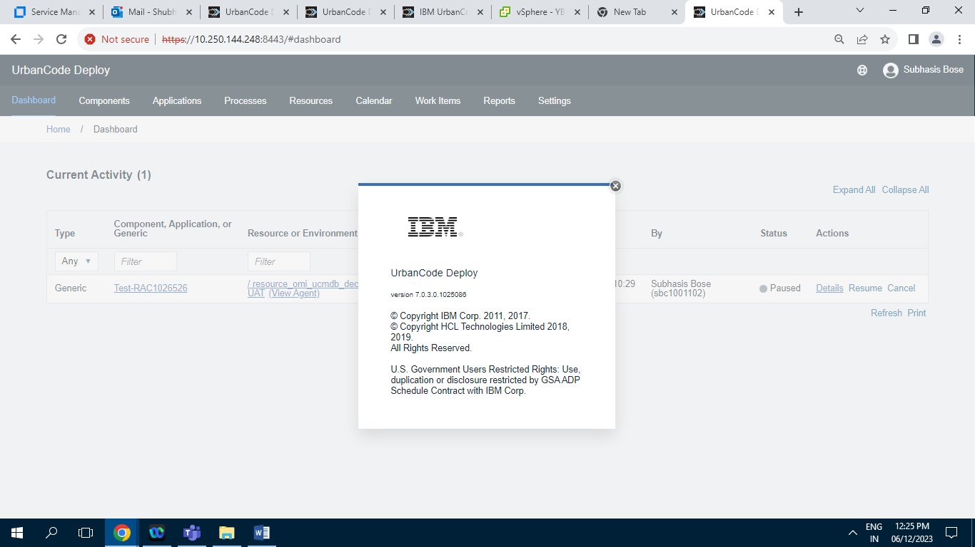

**2 ] Dashboard :**

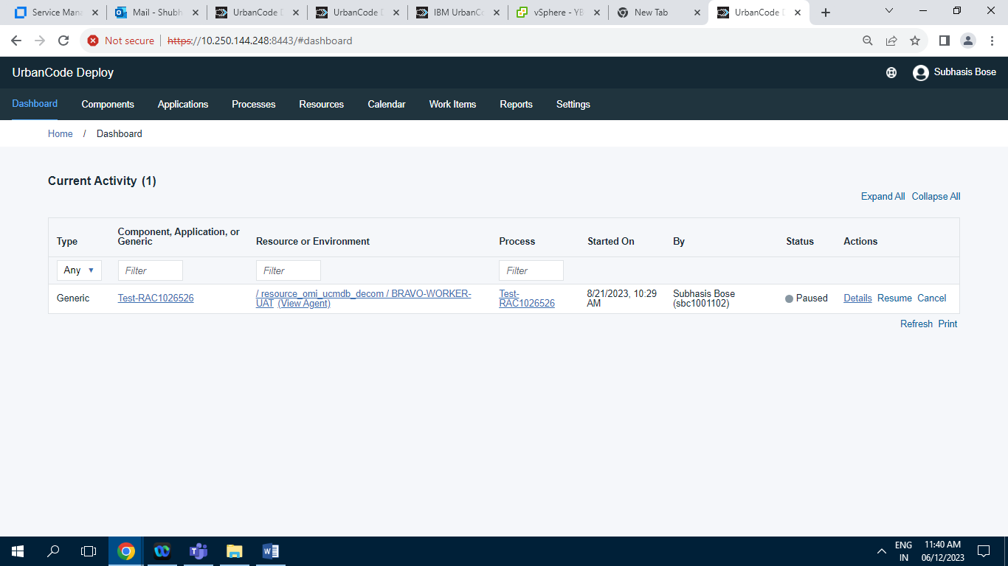

Screenshot of Dashboard tab having 1 Record.

**3 ] Component :**

**3.1 ] Component tab**

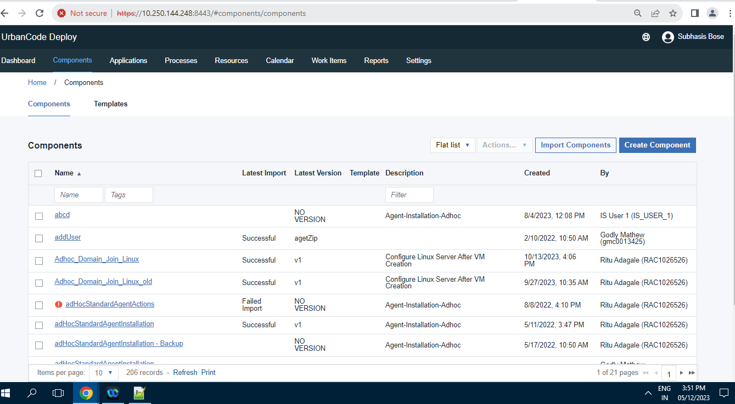

Screenshot of Components Tab having total 206 Records.

**3.2 ] Template tab**

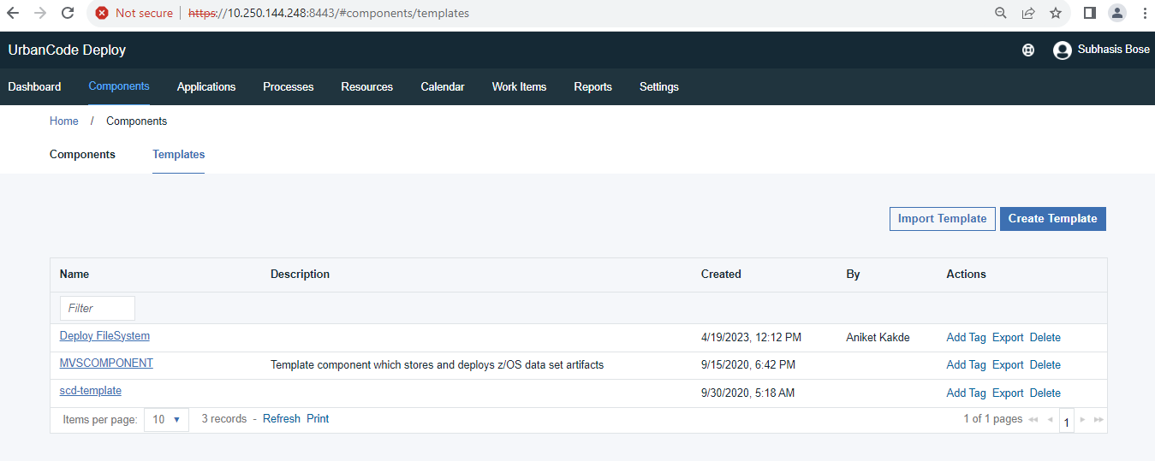

Screenshot of (/Home/Components) Template Tab having 3 Records.

**4 ] Application :**

**4.1 ] Application Tab**

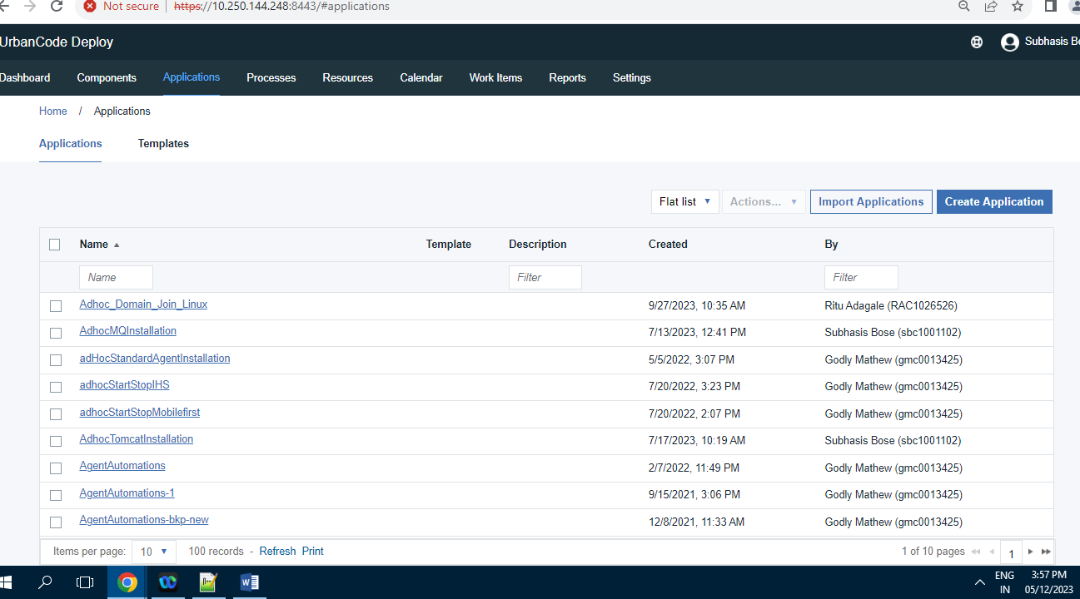

Screenshot of Applications Tab having 100 Records.

**4.2 ] Template Tab**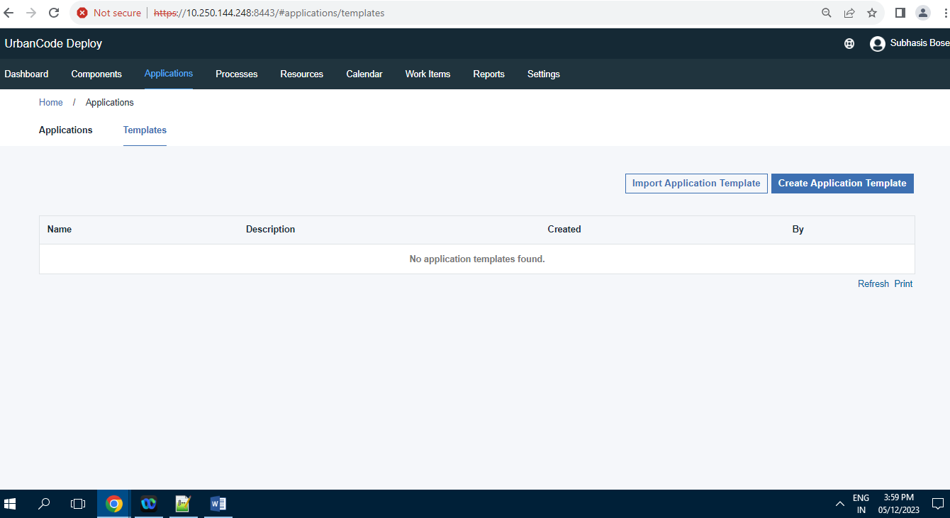

Screenshot of (/Home/Application) Template having 0 Records.

**5 ] Processes**

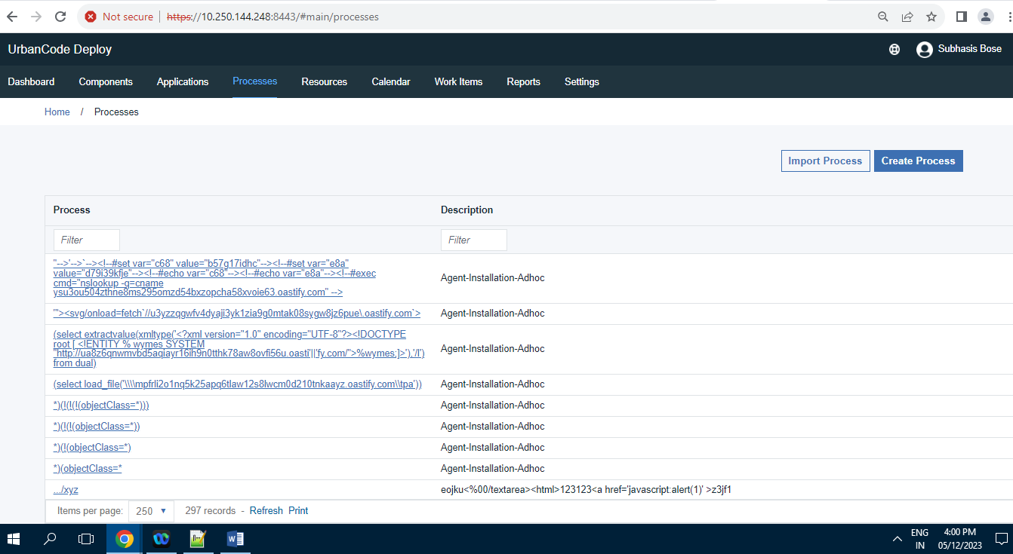

Screenshot of Processes Tab having 297 Records.

**6 ] Resources**

**6.1 ] Resource tree**

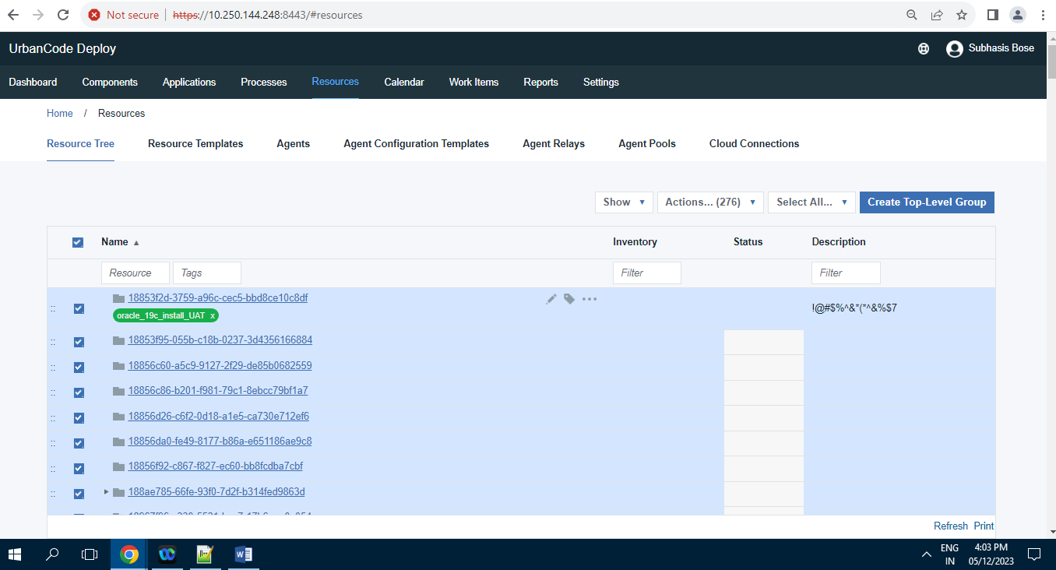

Screenshot of Resources Tree Tab having 276 Records.

**6.2 ] Resource Templates**

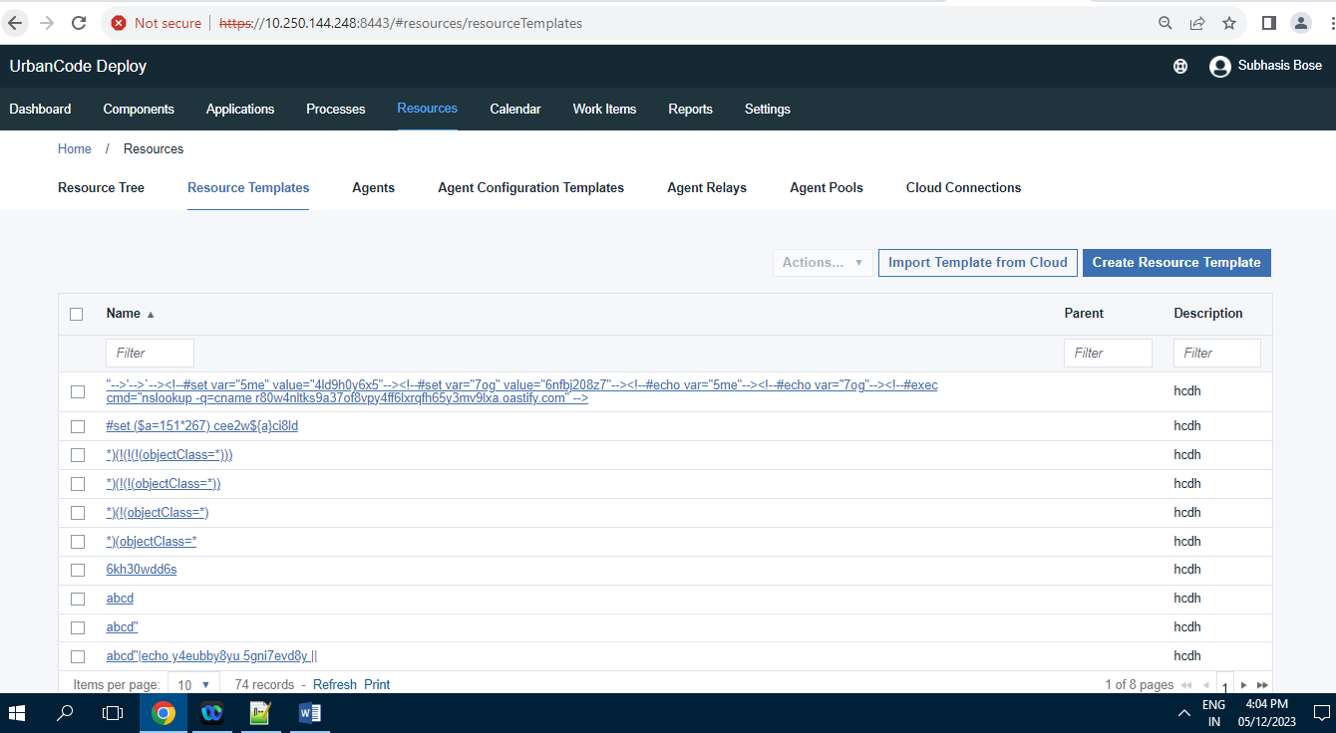

Screenshot of Resources Templates Tab having 74 Records.

**6.3 ] Agents**

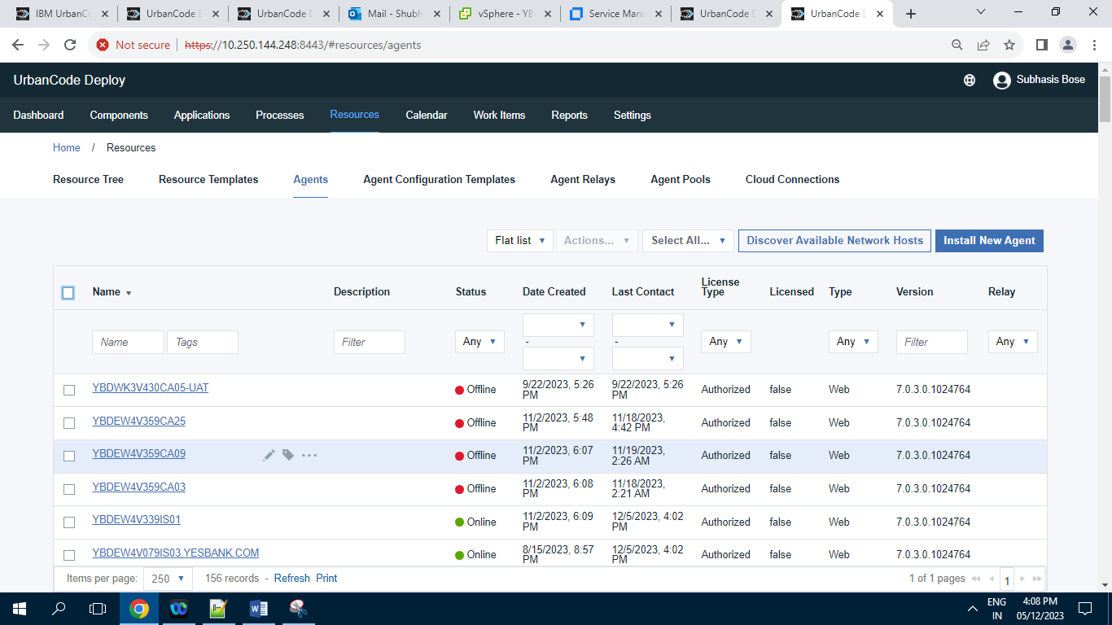

Screenshot of Agents tab having 156 Records

**6.4 ] Agent Configuration Templates**

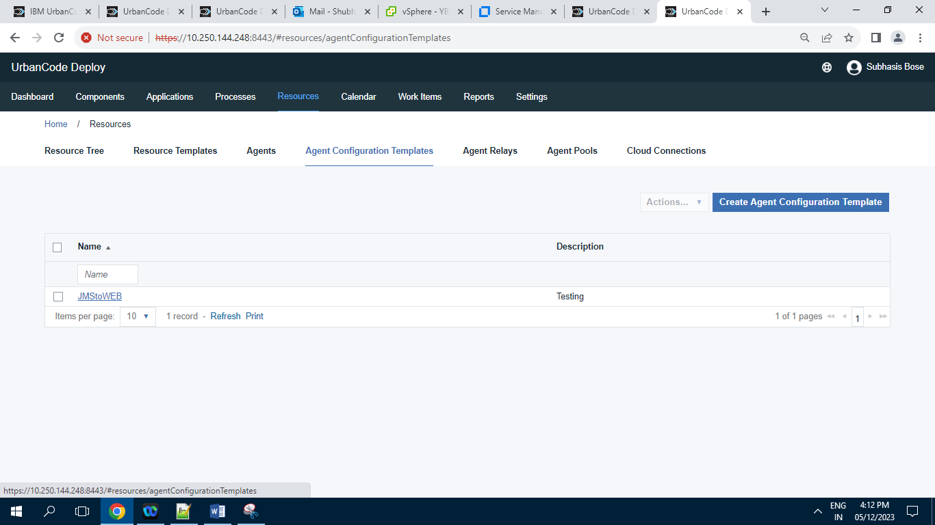

Screenshot of Agent Configuration Template tab having 1 Record.

**6.5 ] Agent Relays**

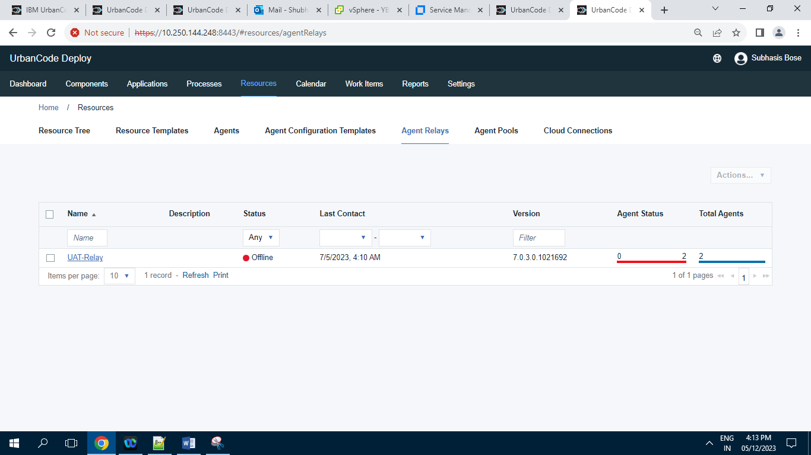

Screenshot of Agent Relay tab having 1 Record.

**6.6 ] Agent Pools**

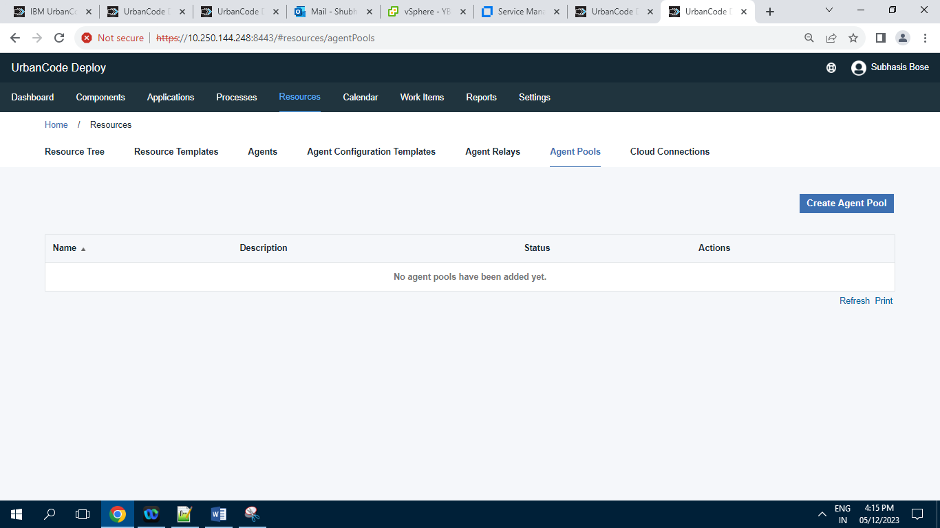

Screenshot of Agent Pools tab having 0 Records.

**6.7 ] Cloud Connections**

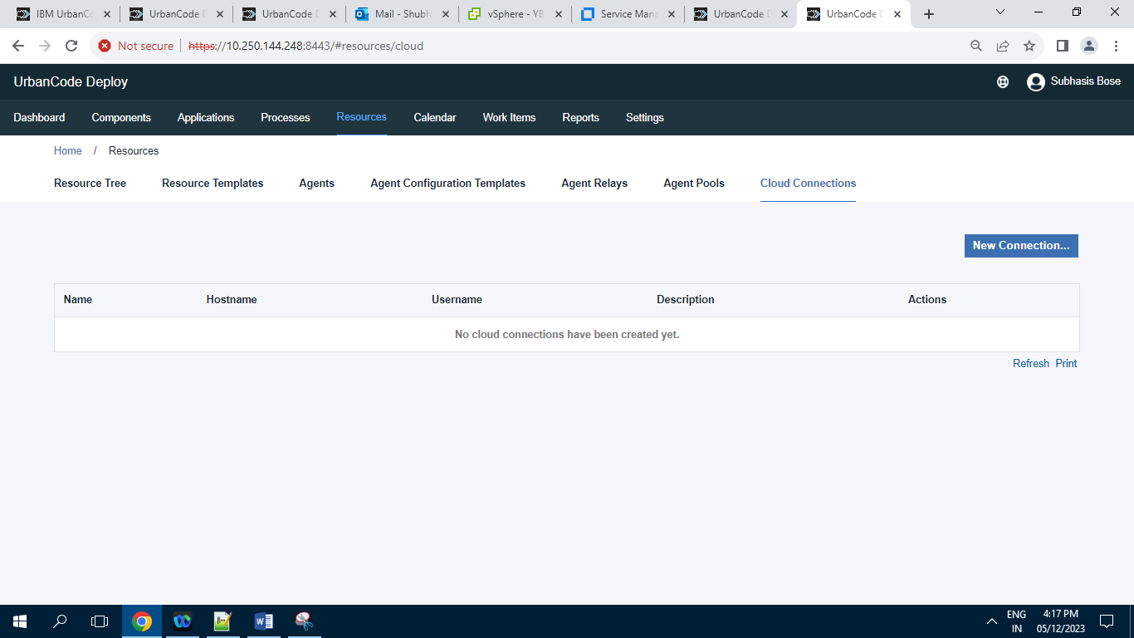

Screenshot of Cloud Connections tab having 0 Records.

**7 ] Calendar**

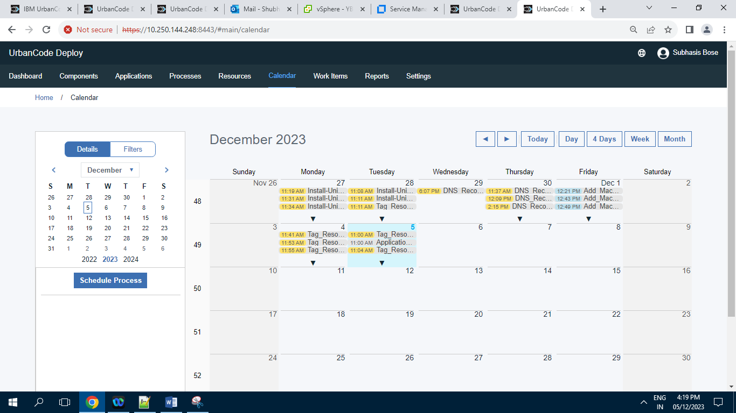

Screenshot of Calendar Tab

**8 ] Work Items**

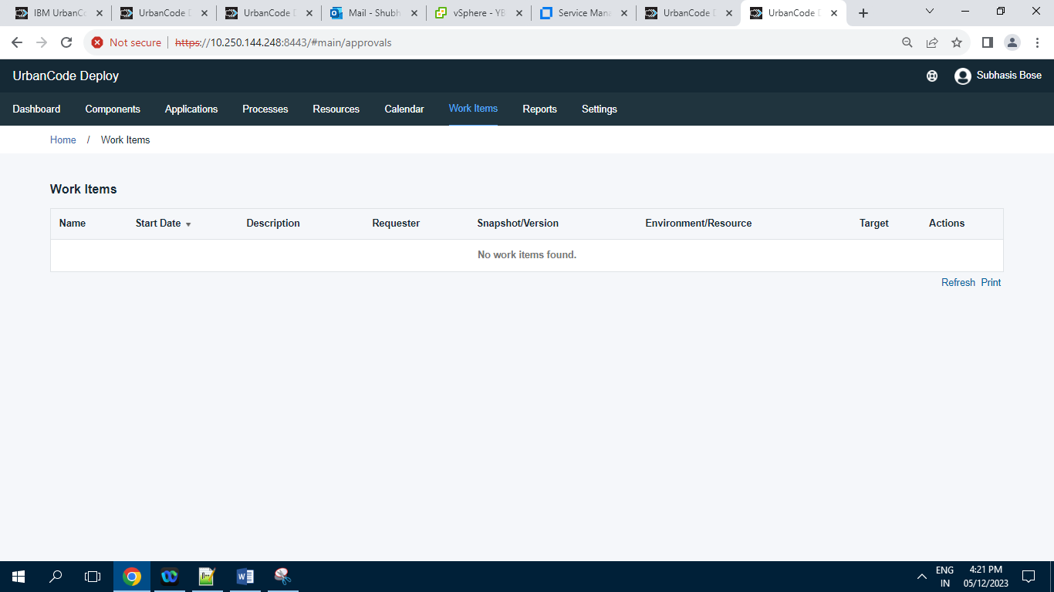

Screenshot of Work Items tab having 0 Records

**9 ] Reports :**

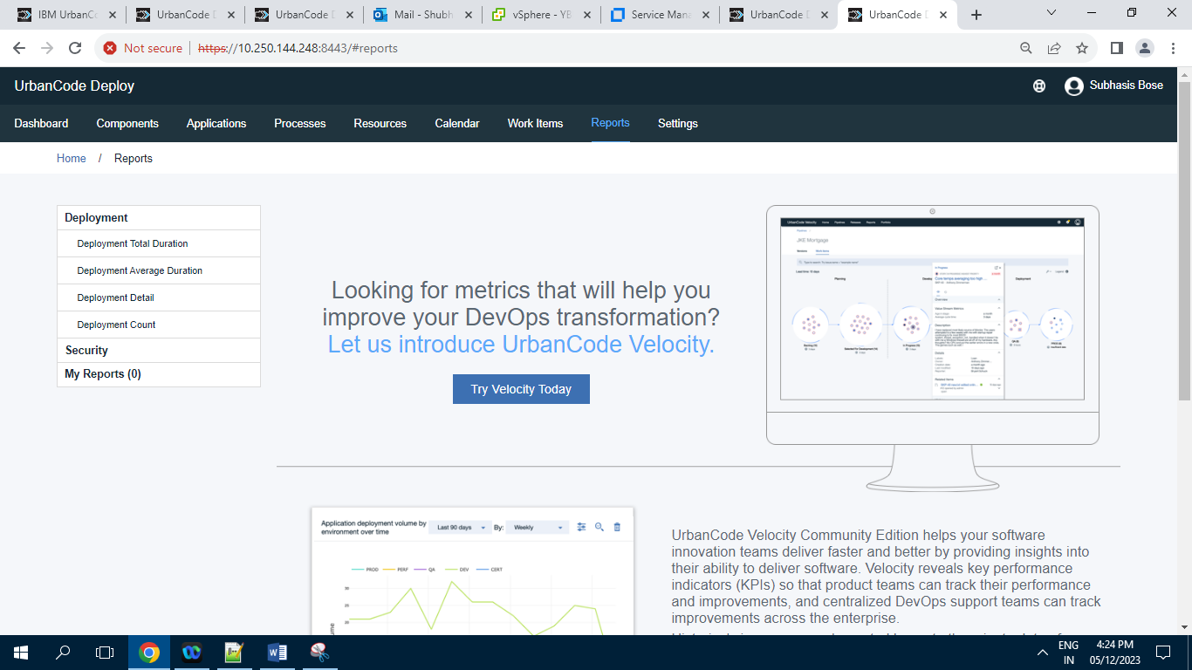

First Screenshot of Reports Tab.

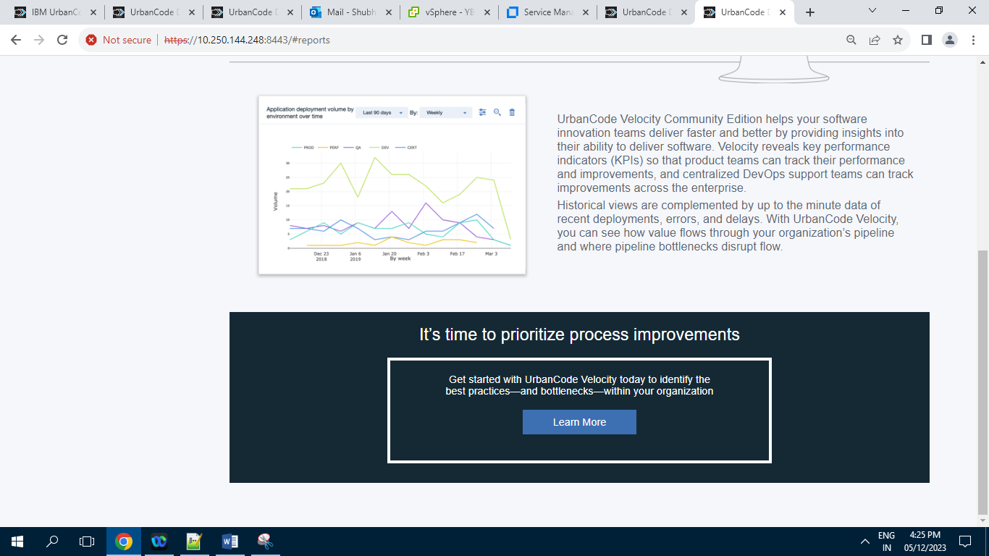

2nd Screenshot of Reports tab

**9.1 ] Deployment :**

**9.1.1 ] Deployment Total Duration :**

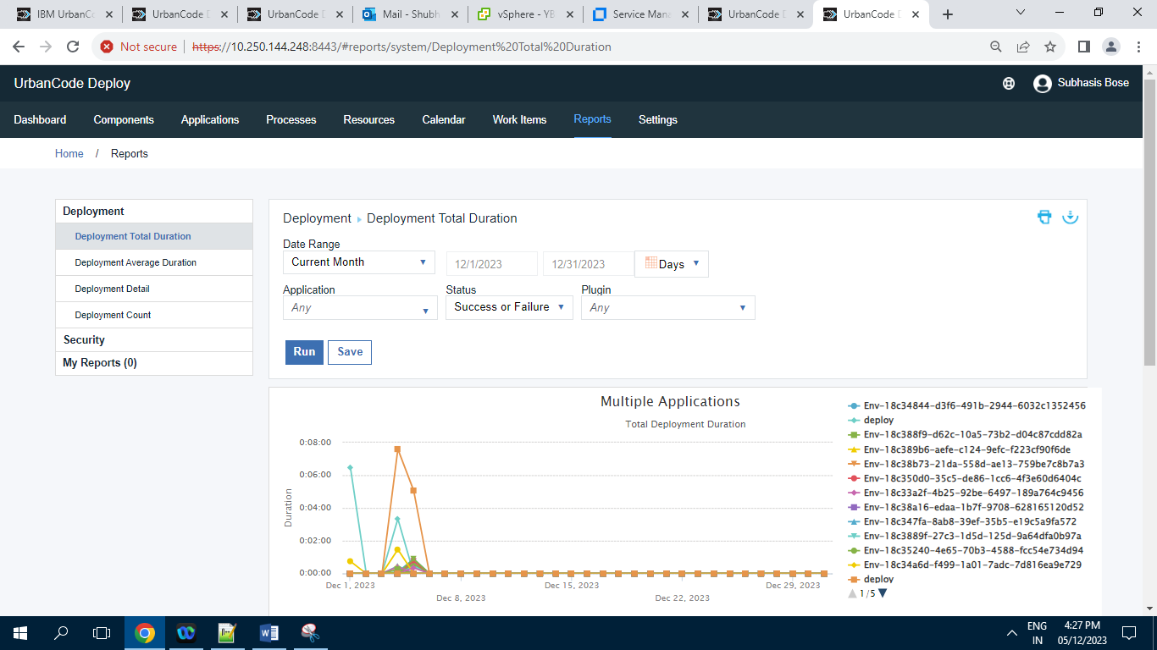

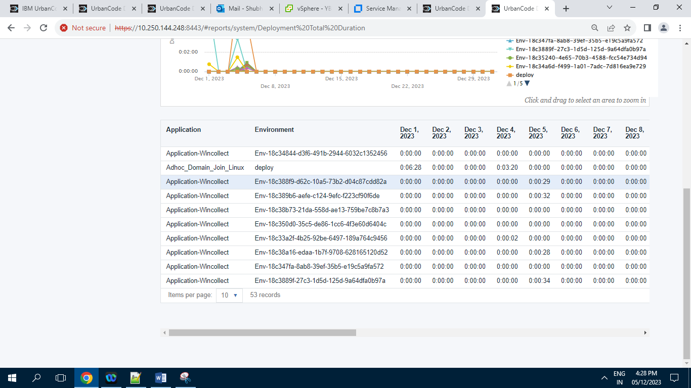

Screenshot of Deployment Total Duration tab inside “Reports” Section having 53 Records.

**9.1.2 ] Deployment Average Duration :**

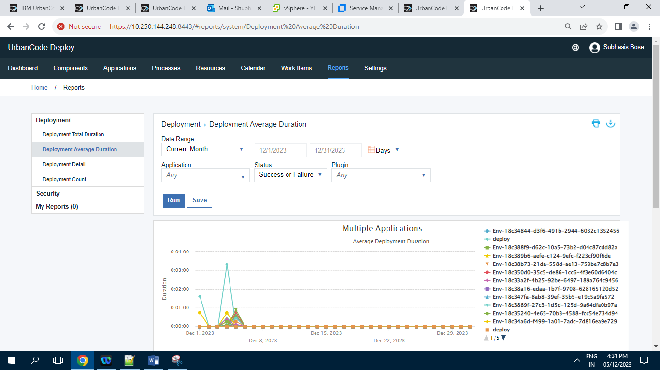

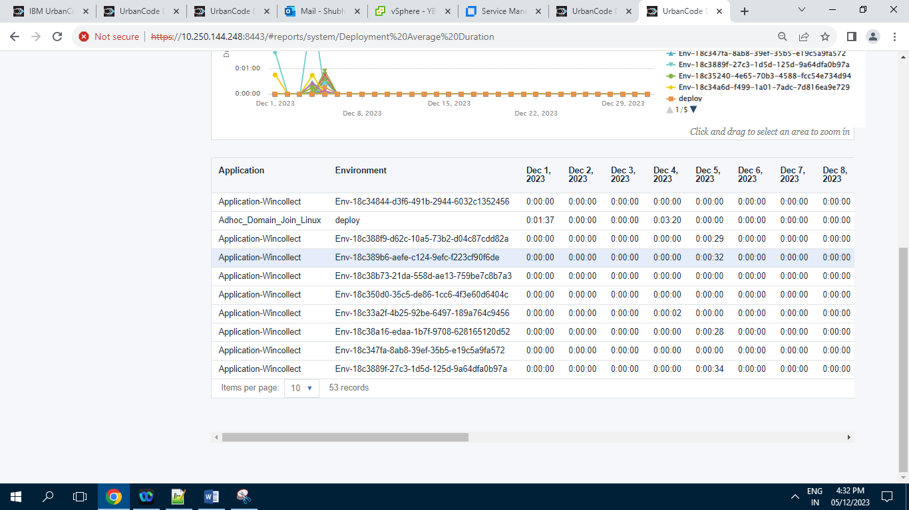

Screenshot of Deployment Average Duration tab inside “Reports” Section having 53 Records.

**9.1.3 ] Deployment Details :**

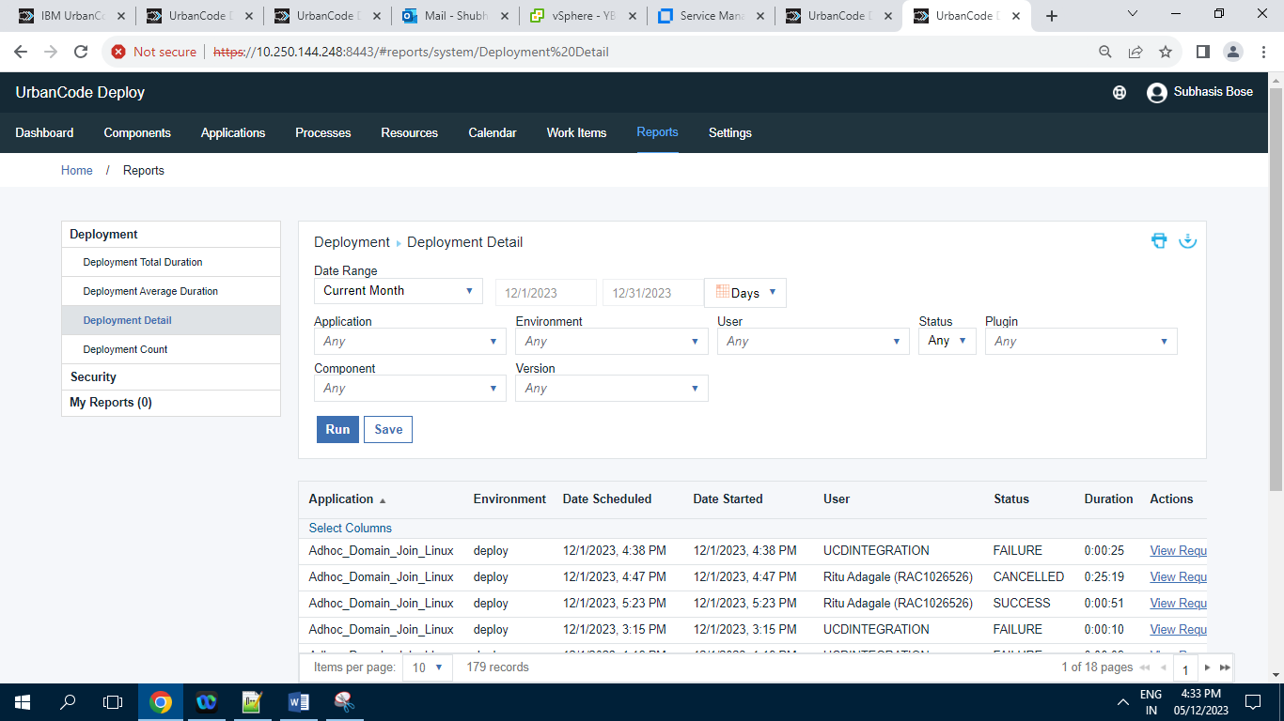

Screenshot of Deployment Details Tab inside a “Reports” Section having 179 Records.

**9.1.4 ] Deployment Count :**

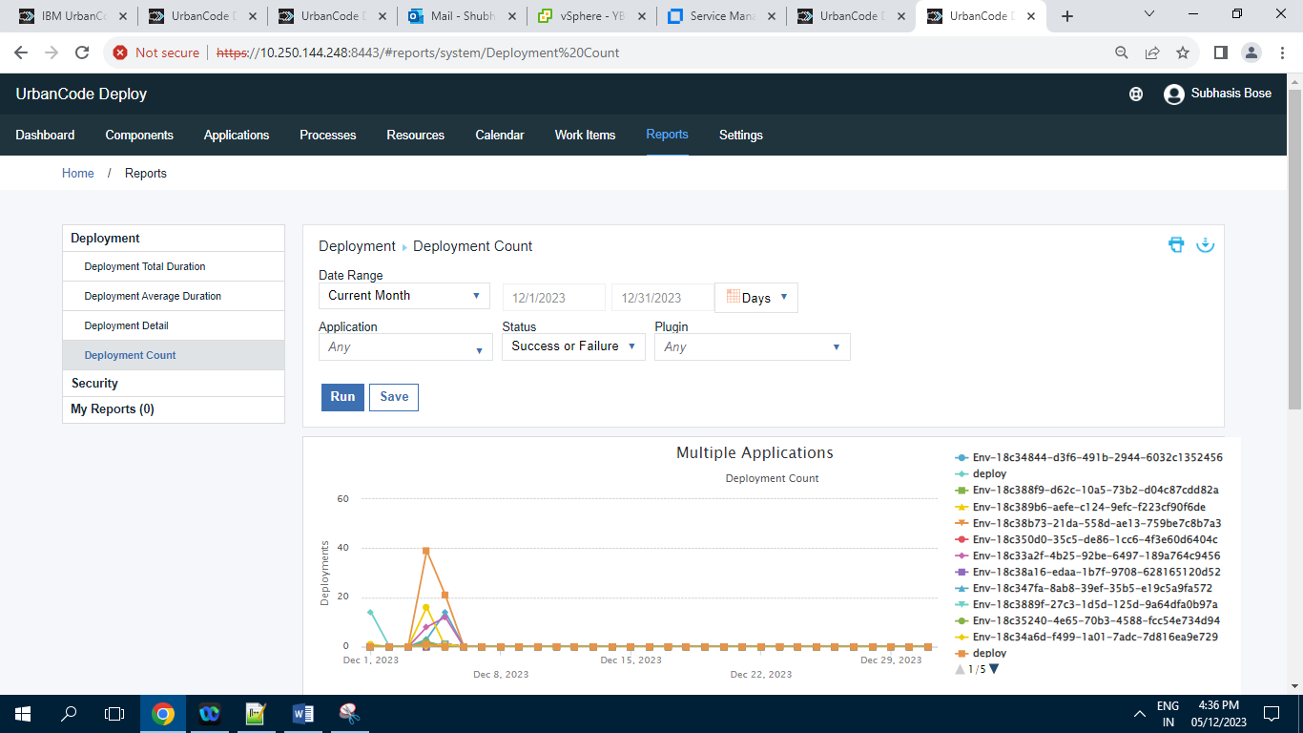

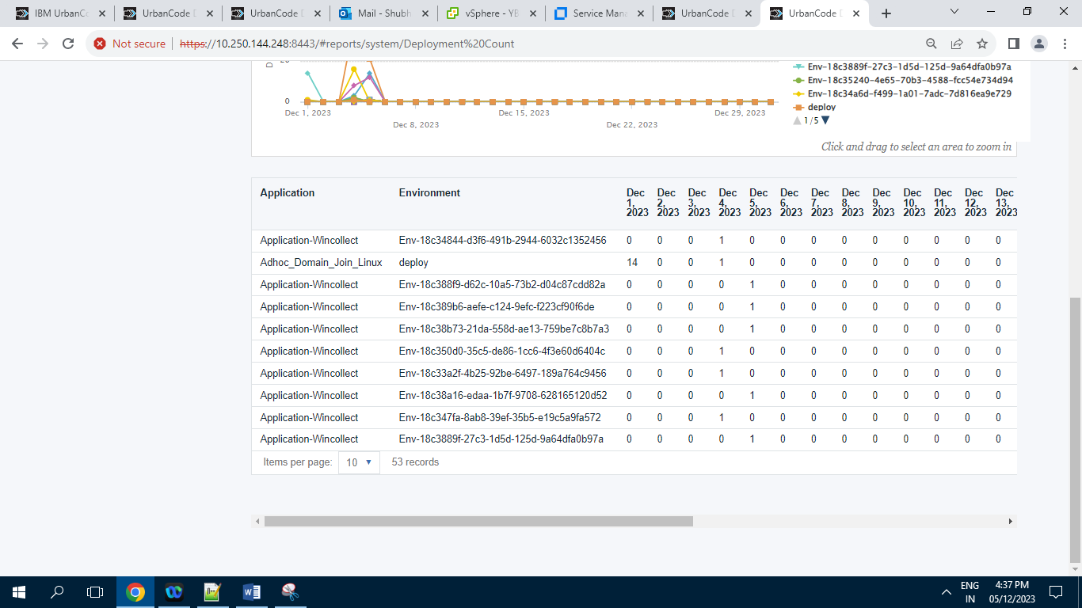

Screenshot of Deployment Count tab inside a “Reports” Section having 53 Records.

**9.2 ] Security :**

**9.2.1 ] Component Security :**

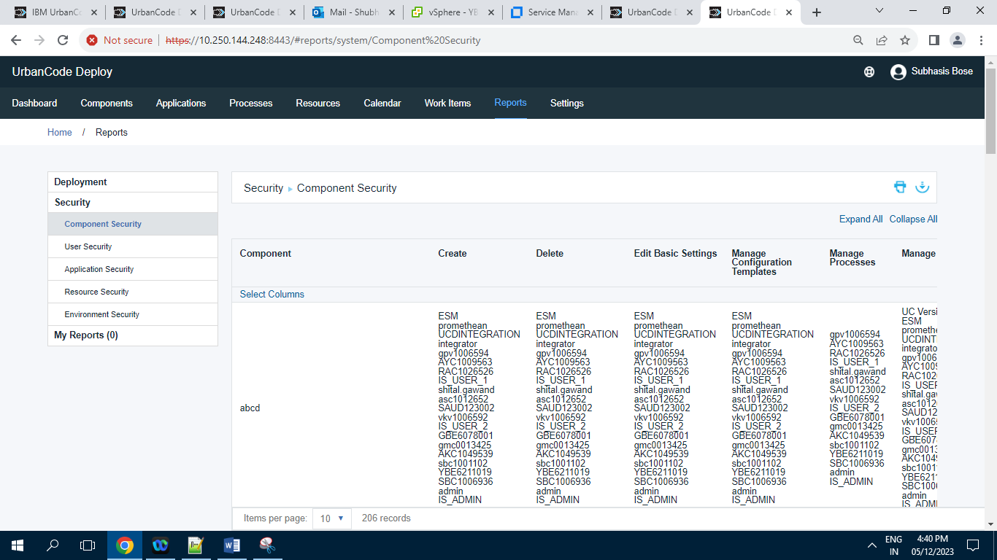Screenshot of component security tab inside “Reports” Section having 206 Records.

**9.2.2 ] User Security :**

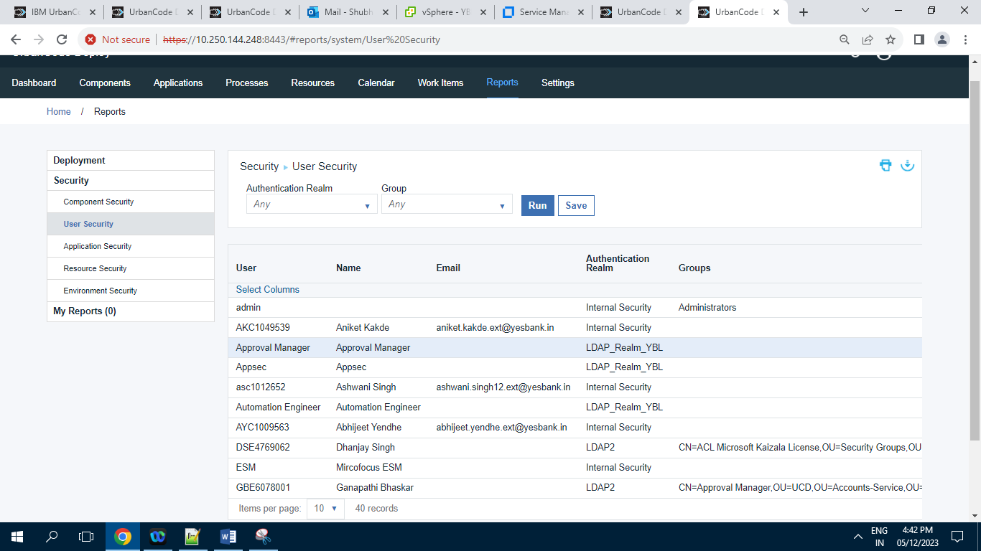

Screenshot of User Security tab inside “Reports” Section having 40 Records.

**9.2.3 ] Application Security :**

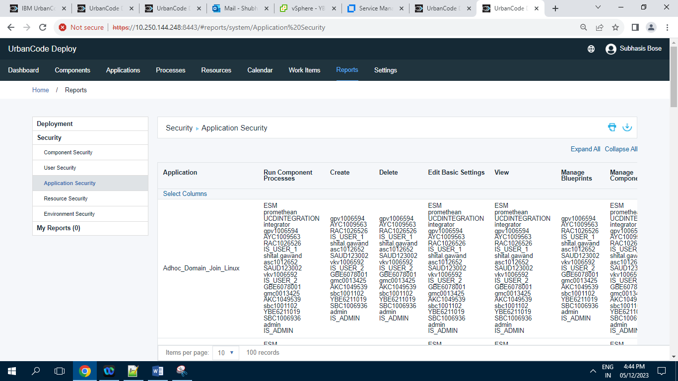

Screenshot of Application Security tab inside “Reports” Section having 100 Records.

**9.2.4 ] Resource Security :**

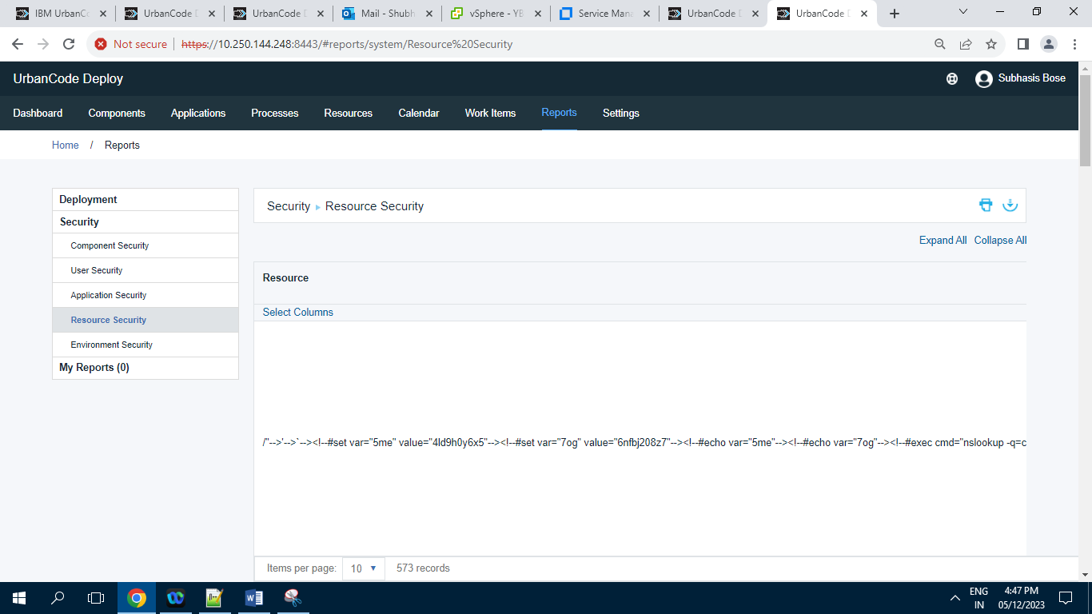

Screenshot of Resource Security tab inside “Reports“ Section having 573 Records.

**9.2.5 ] Environment Security :**

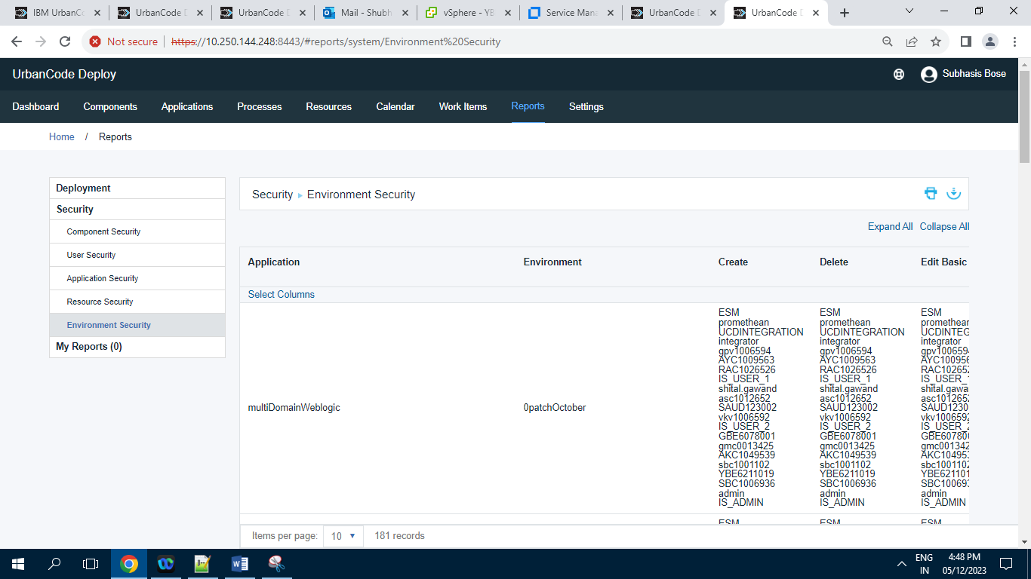

Screenshot of Environment Security tab inside “Reports” Section having 181 Records.

**9.3 ] My Reports :** zero records in My Reports tab.

**10 ] Settings :**

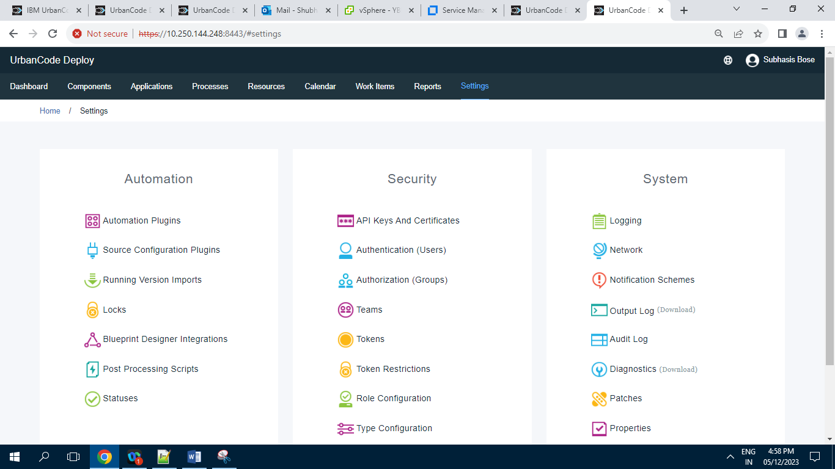

**10 .1 ] Automation :**

**10.1.1 ] Automation Plugins**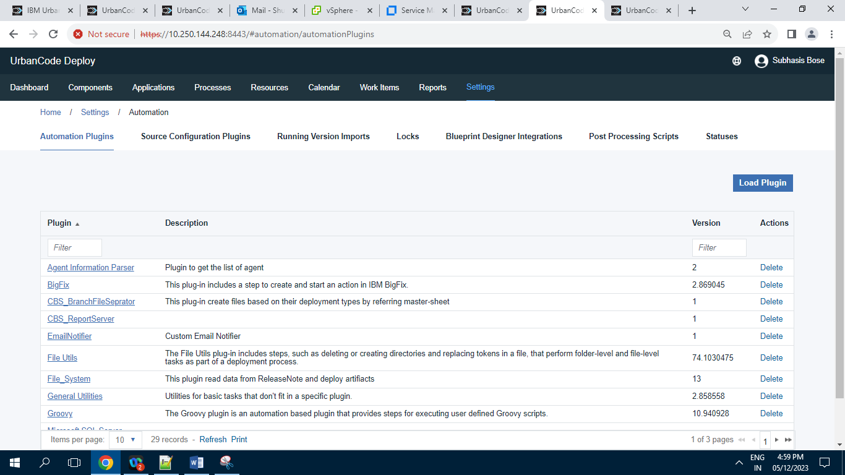

Screenshot of Automation Plugins having 29 Records.

**10.1.2 ] Source Configuration Plugins :**

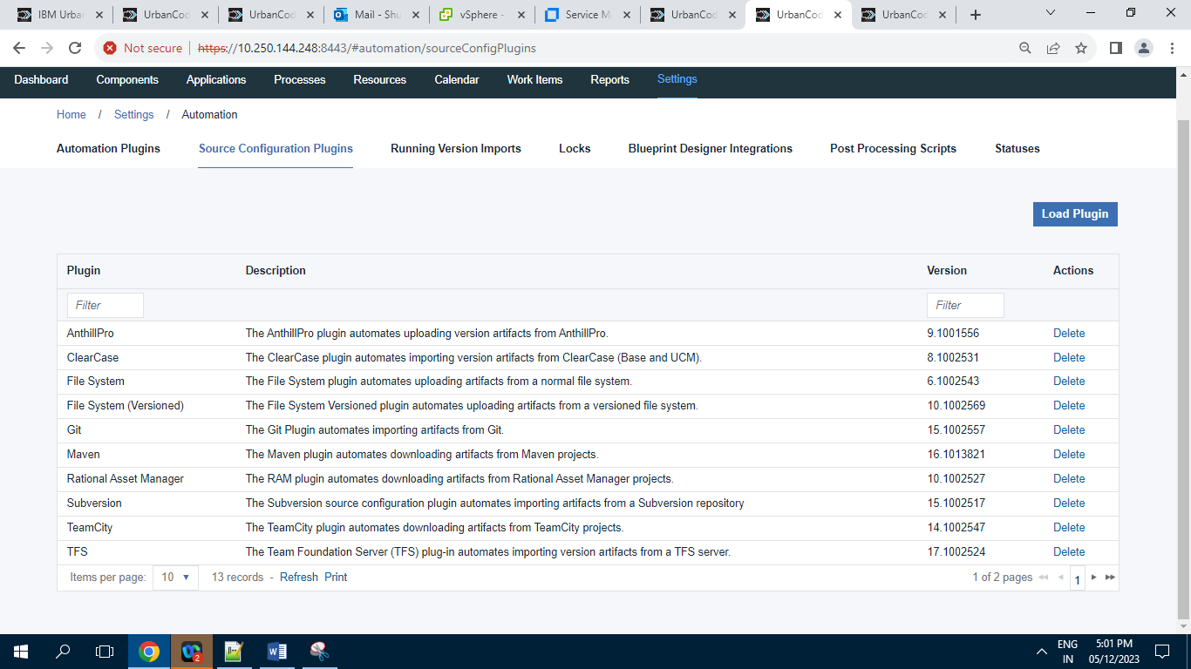

Screenshot of Source Configuration tab having 13 Records.

**10.1.3 ] Running Version Imports :**

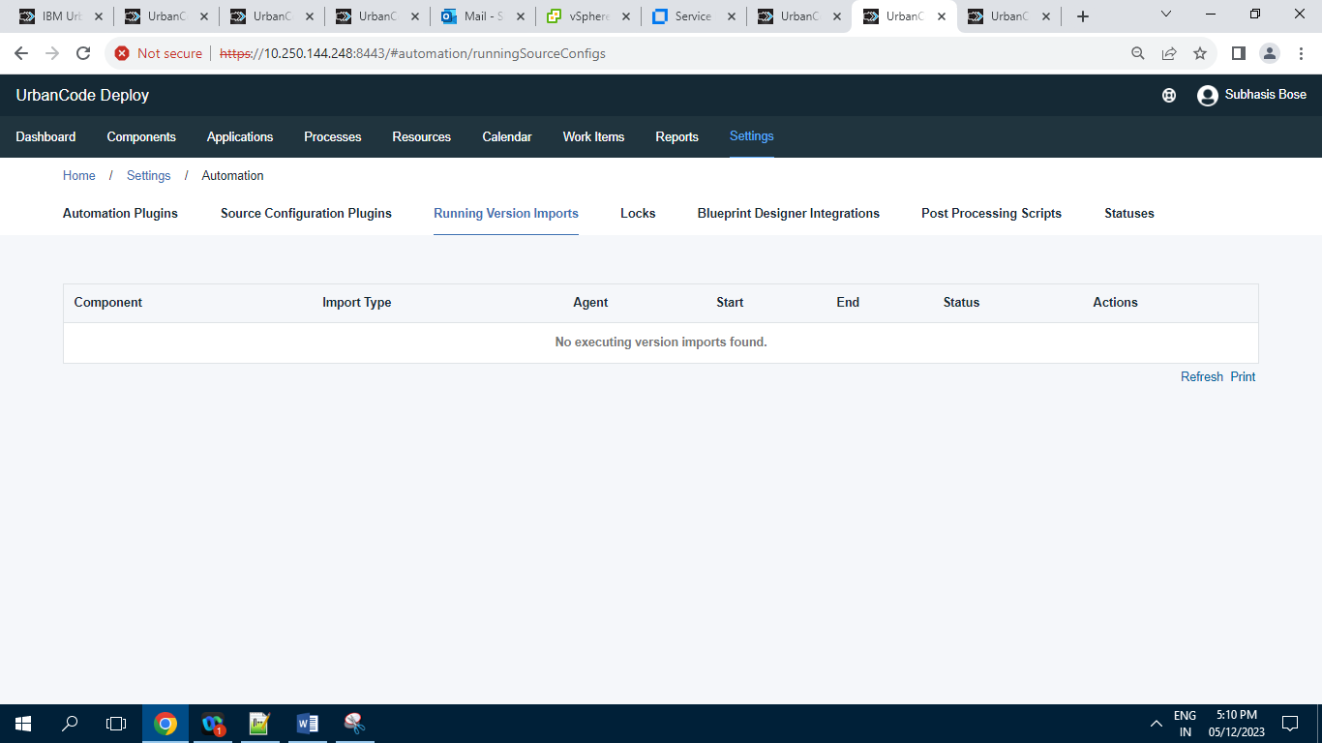

Screenshot of Running Version Imports tab having 0 Records.

**10.1.4 ] Locks :**

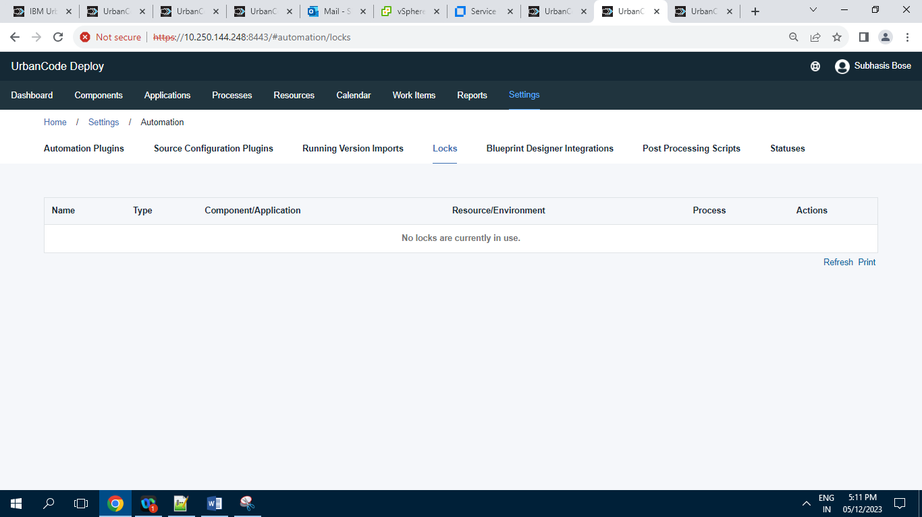

Screenshot of Locks Tab having 0 Records .

**10.1.5 ] Blueprint Designer Integration :**

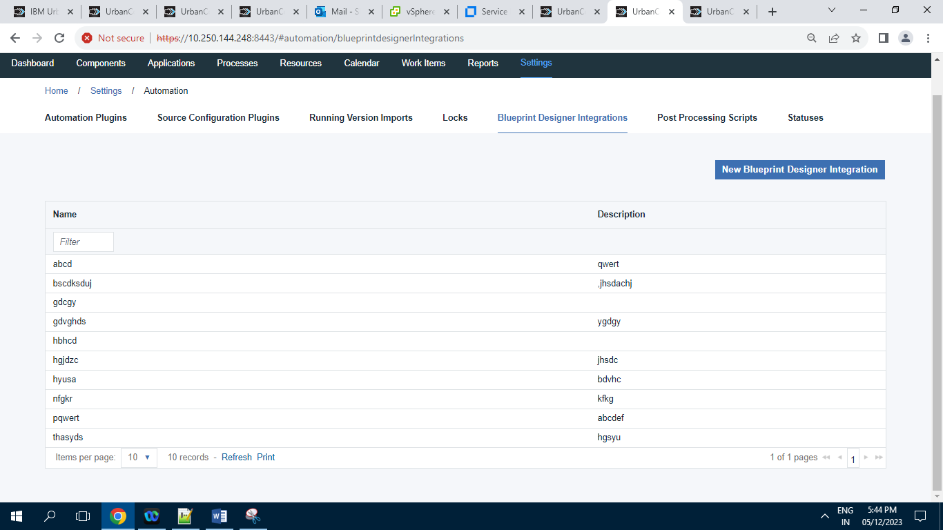Screenshot of Blueprint Designer Integration having 10 Records.

**10.1.6 ] Post Processing Scripts :**

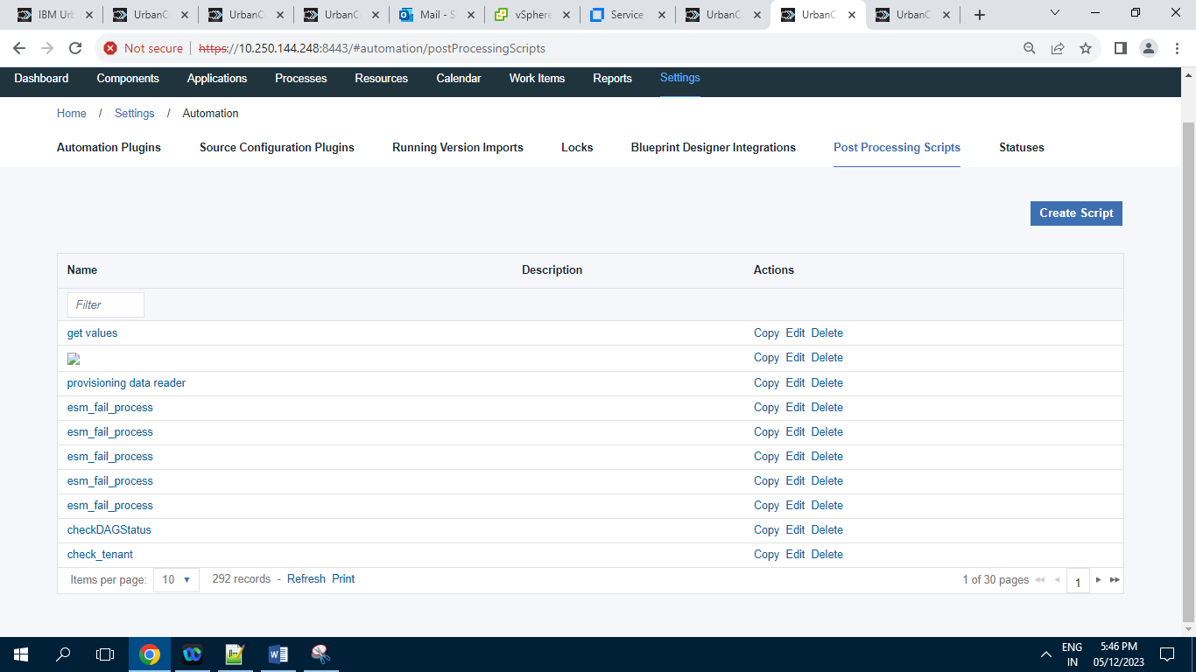

Screenshot of Post Processing Script having 292 Records.

**10.1.7 ] Statues :**

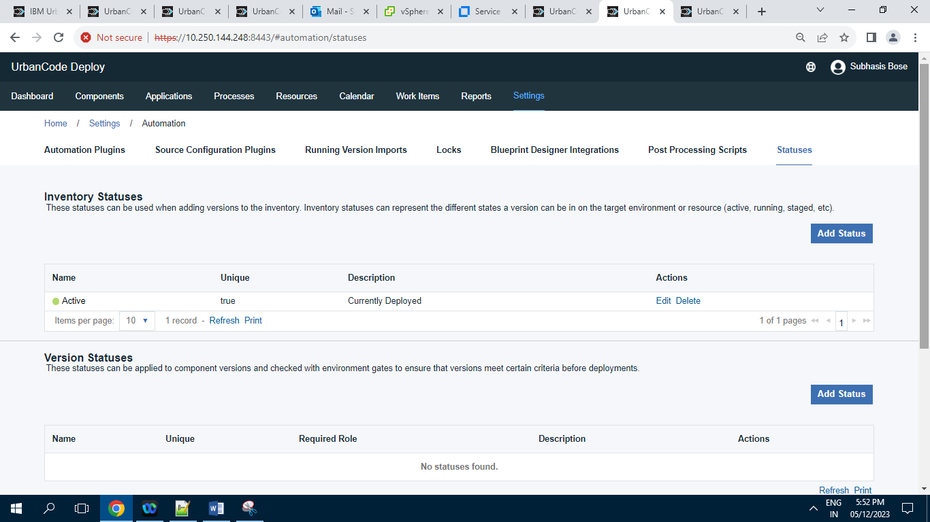

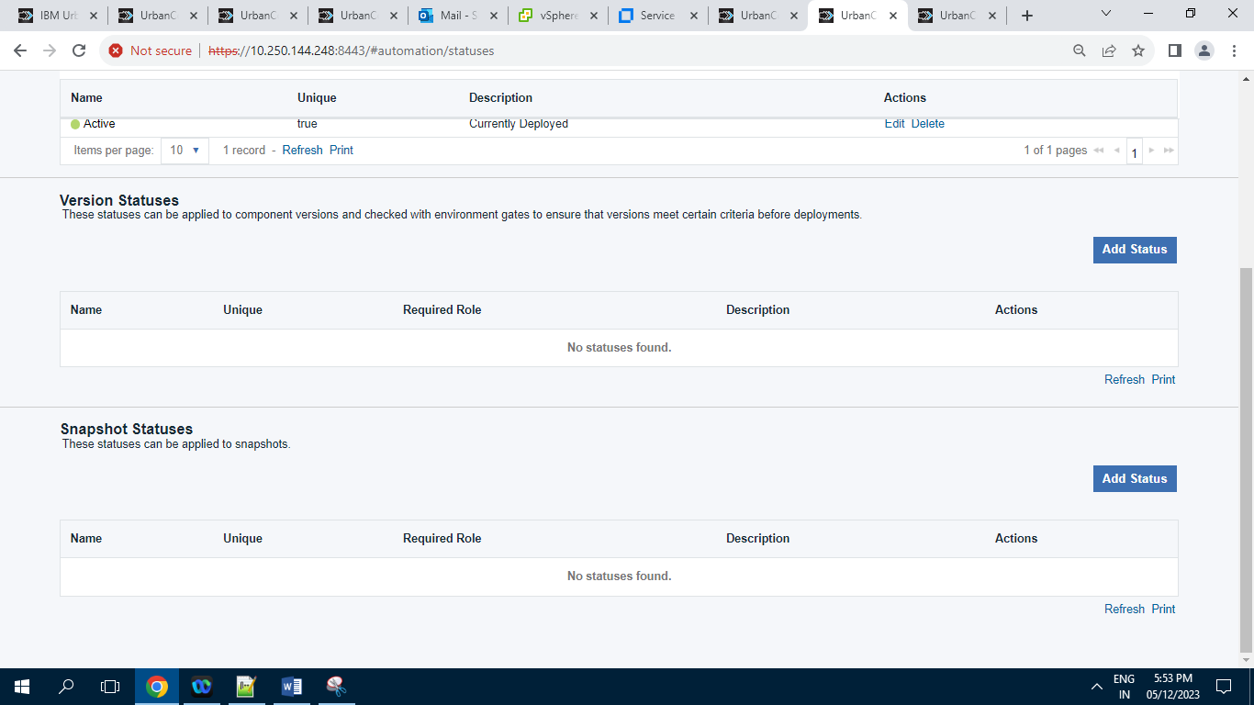

**10.2 ] Security :**

**10.2.1 ] API Keys And Certificates :**

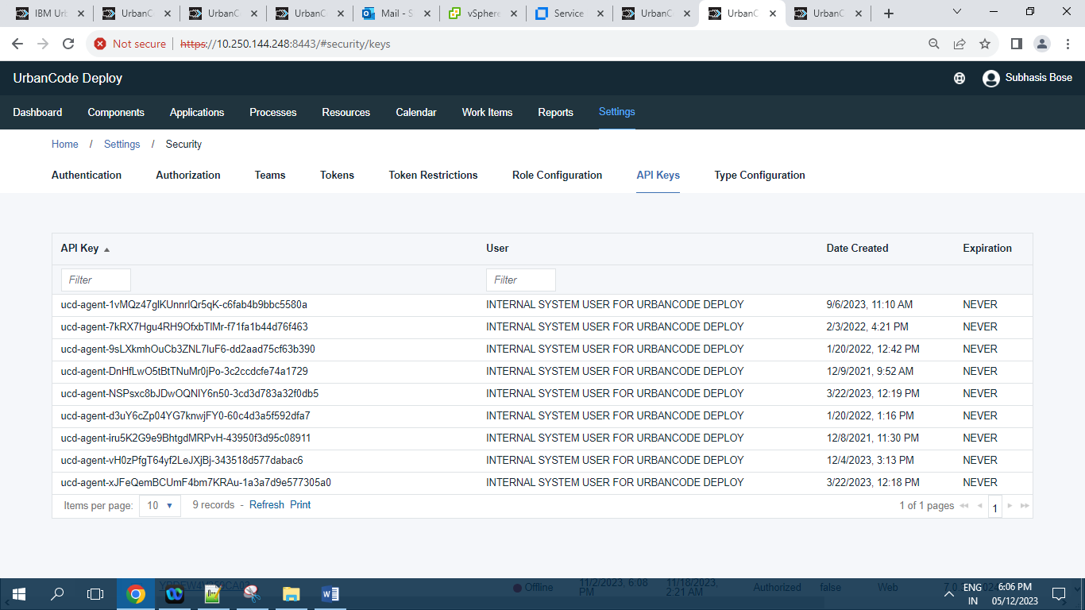

Screenshot of API Keys And Certificates having 9 Records.

**10.2.2 ] Authentication (Users)**

**10.2.2.1 ] Internal Security**

**10.2.2.1.1 Users tab :**

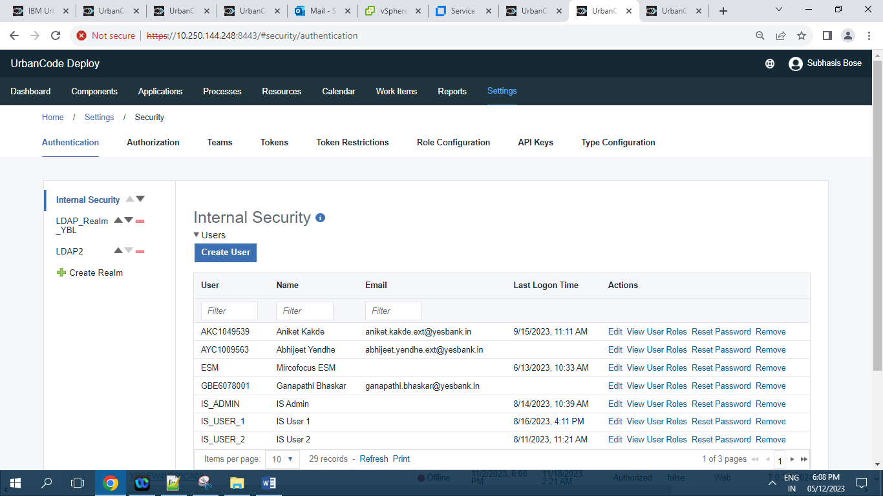

Screenshot of Internal Security having 29 Records.

**10.2.2.1.2 ] Edit tab :**

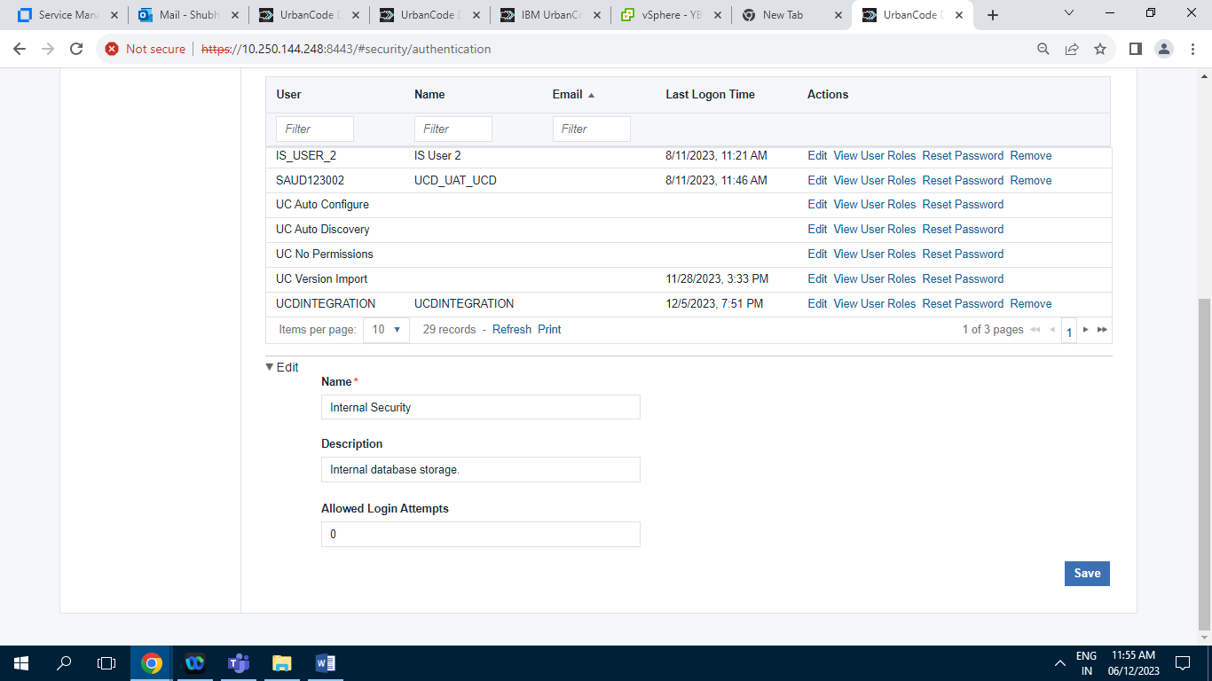

**10.2.2.2 ] LDAP_Realm_YBL :**

**10.2.2.2.1 ] Users tab :**

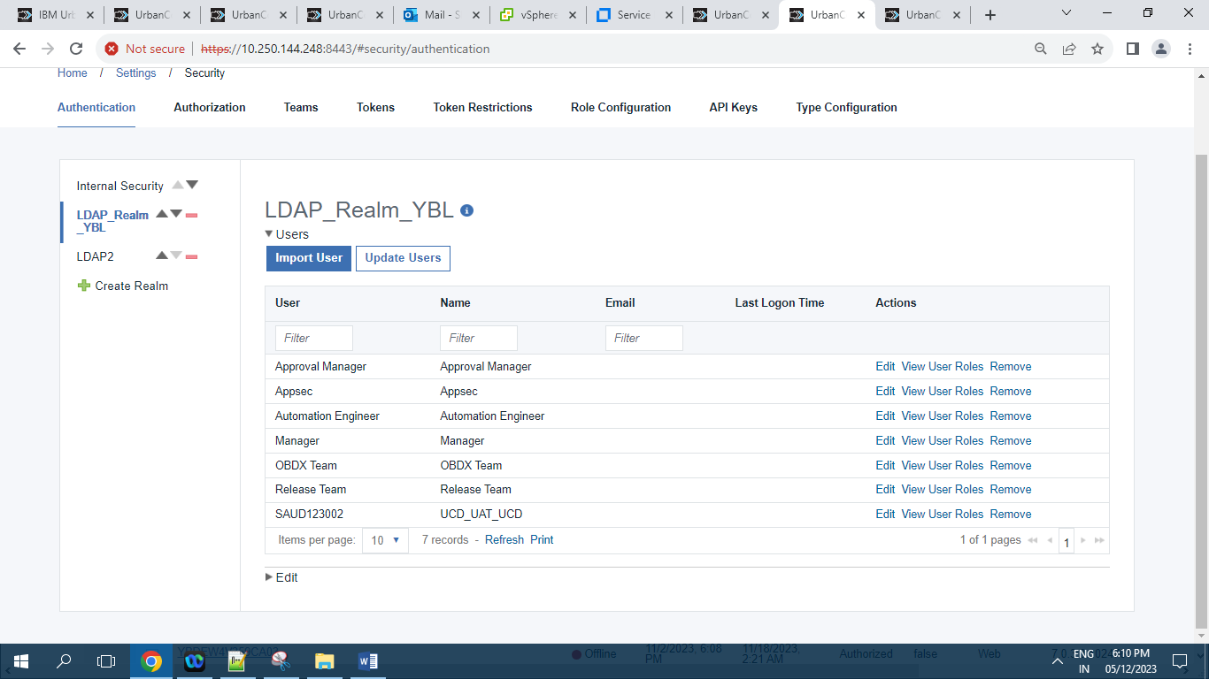

Screenshot of LDAP_Realm_YBL users tab having 7 Records.

**10.2.2.2.2 ] Edit tab :**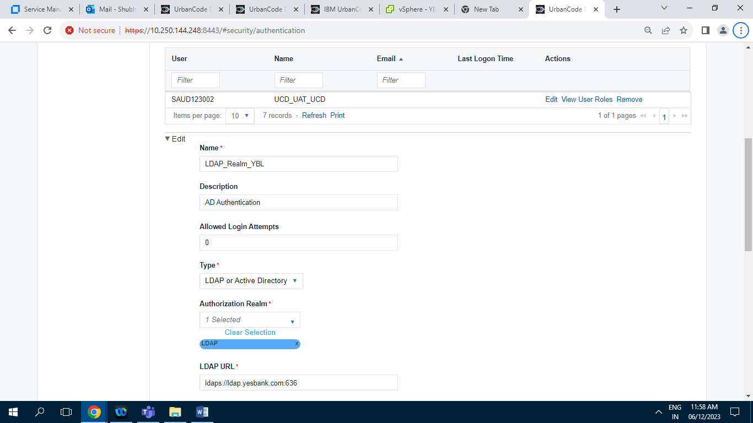

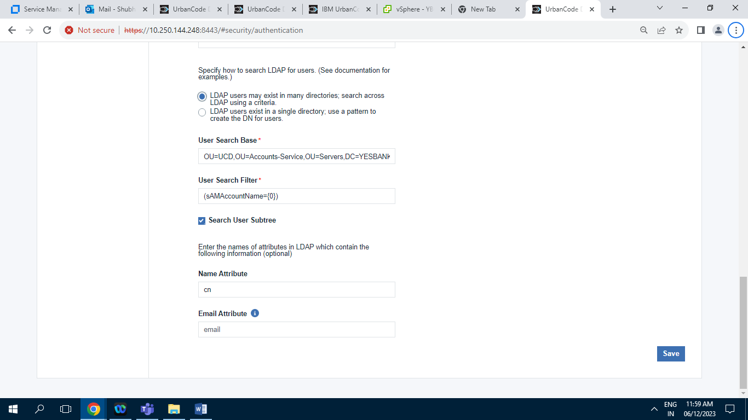

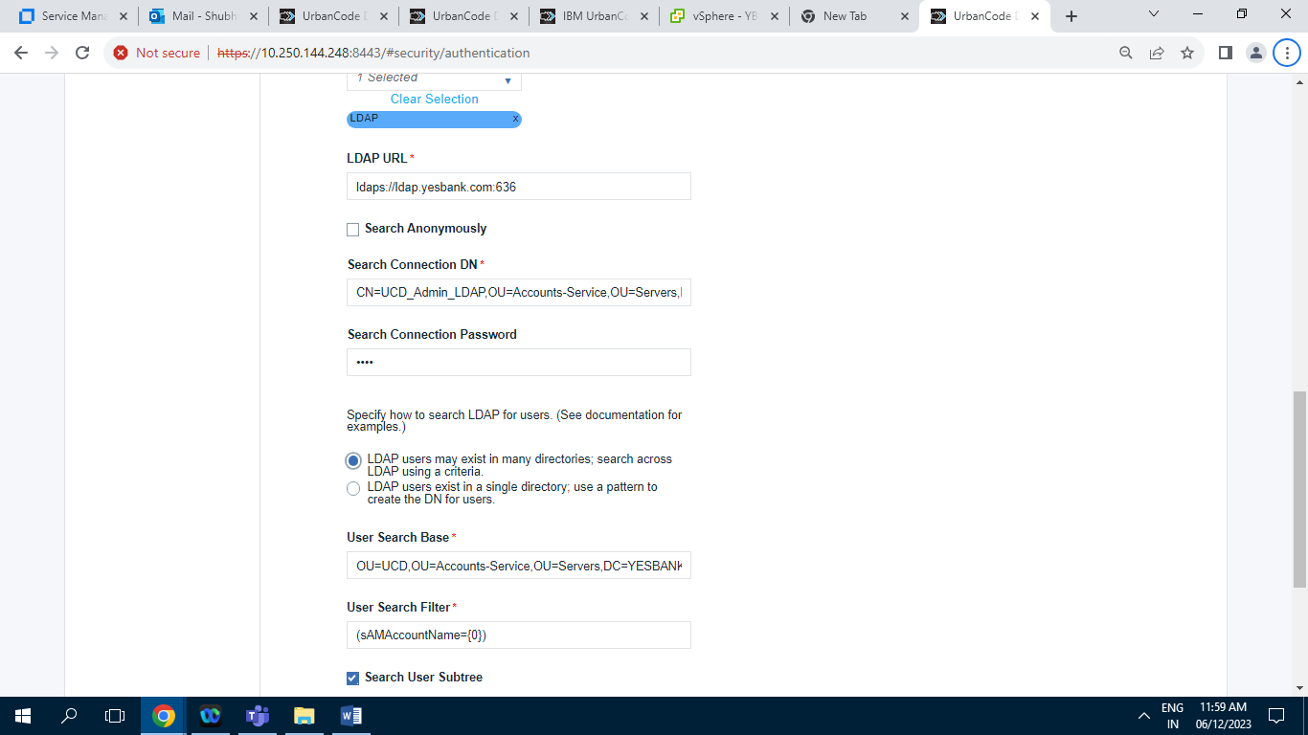

**10.2.2.3 ] LDAP2 :**

**10.2.2.3.1 ] Users tab**

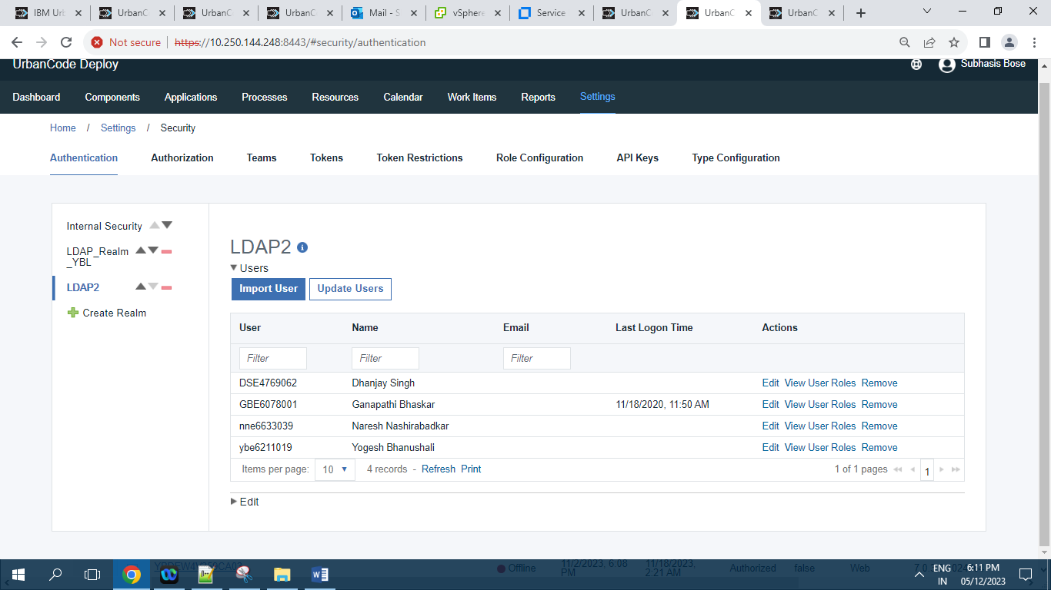

Screenshot of LDAP2 having 4 Records.

**10.2.2.3.2 ] Edit tab :**

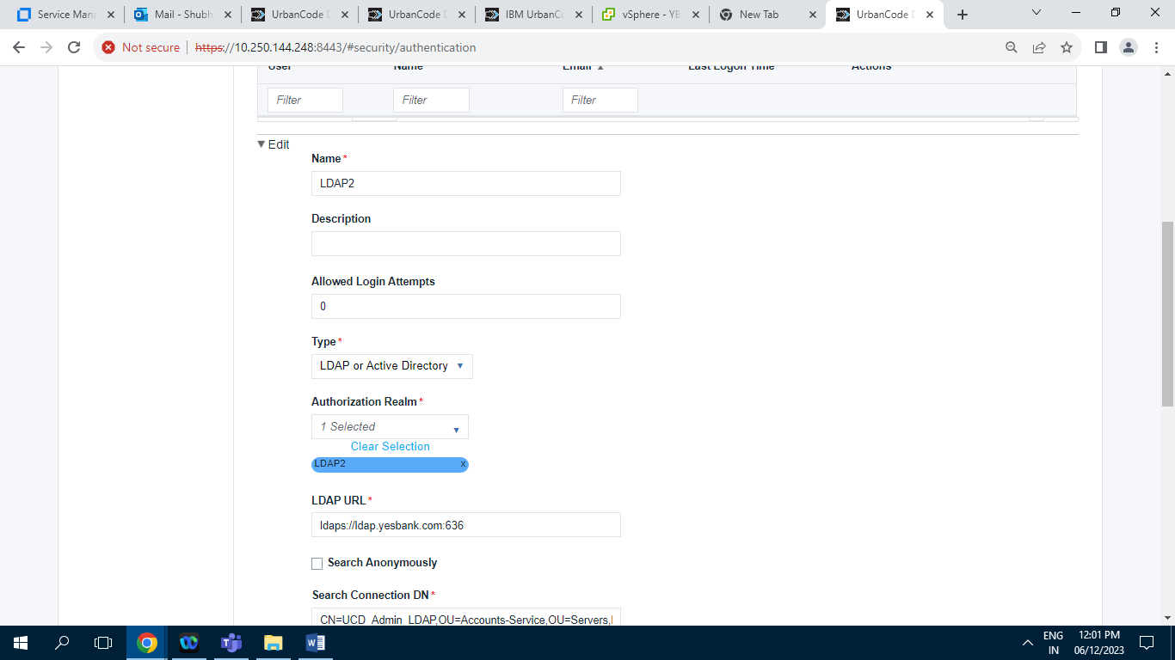

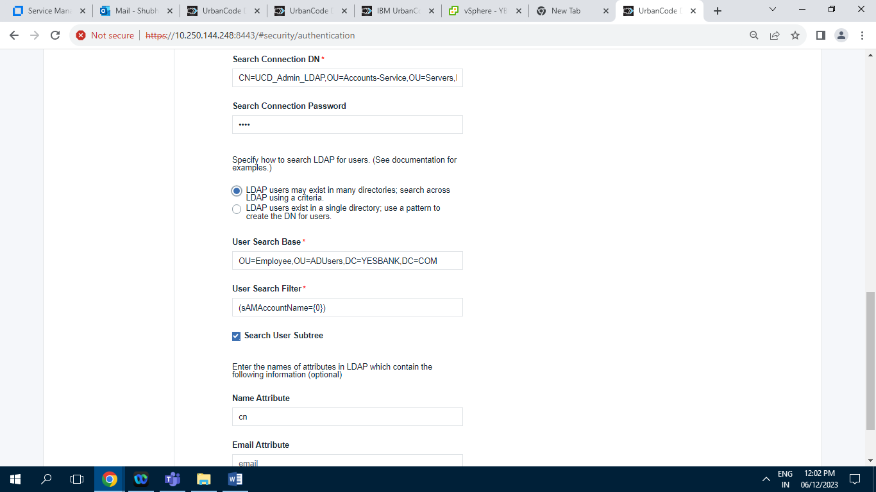

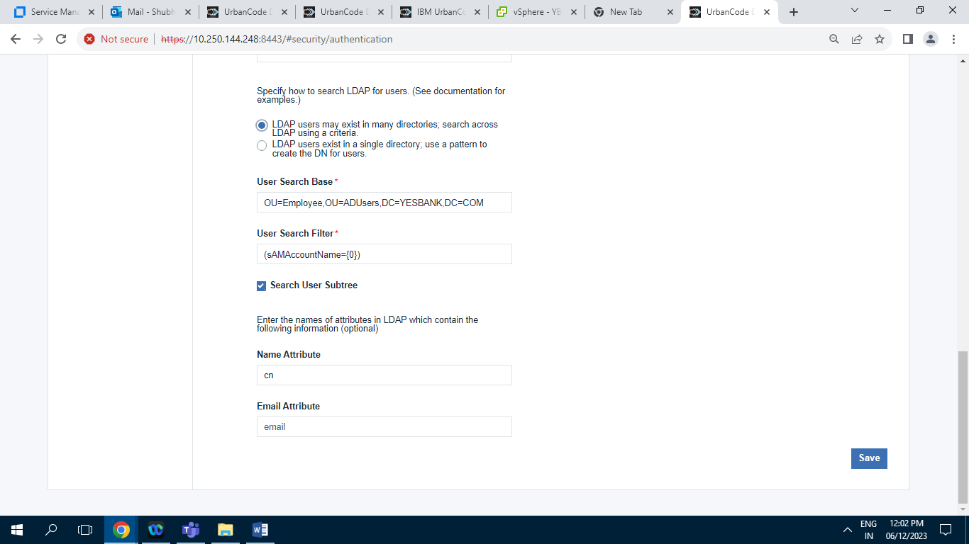

**10.2.3 ] Authorization (Groups):**

**10.2.3.1 ] Authorization Realms**

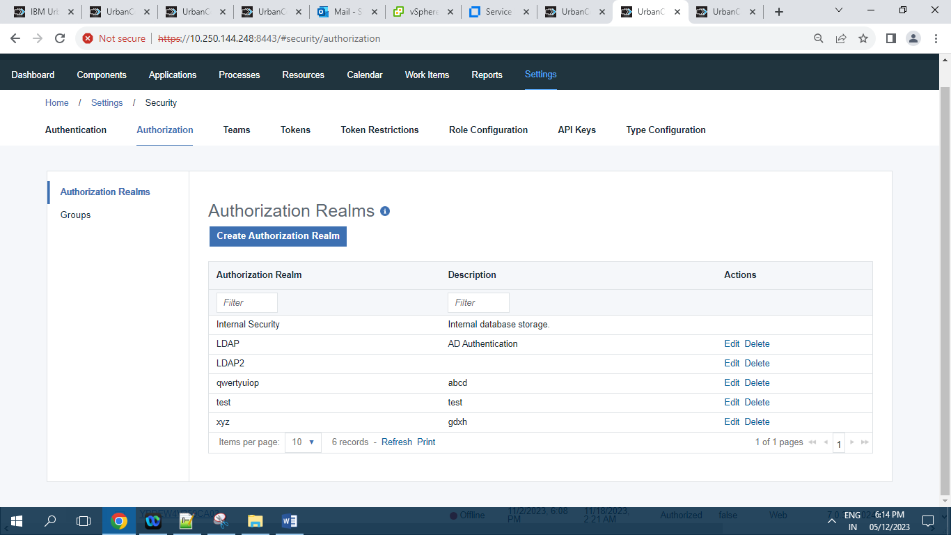

Screenshot of Authorization Realms having 6 Records.

**10.2.3.2 ] Gropus :**

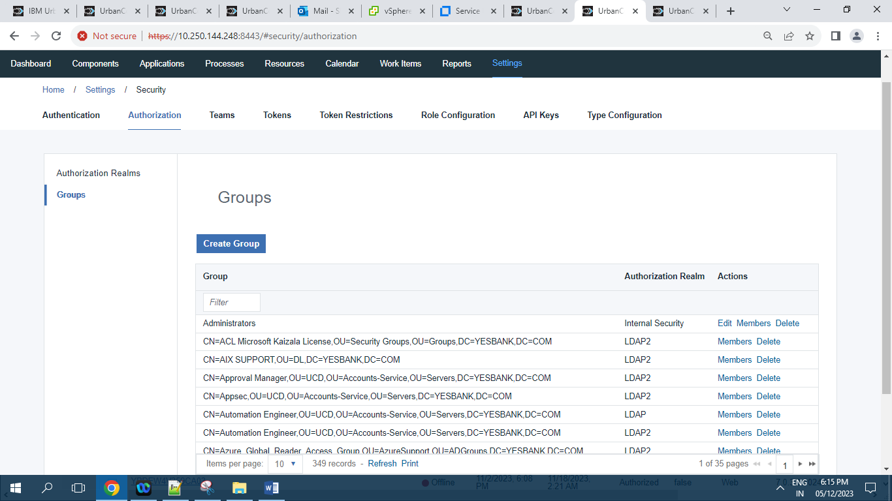

Screenshot of Gropus having 349 Records.

**10.2.4 ] Teams:**

**10.2.4.1 ] Approval Manager**

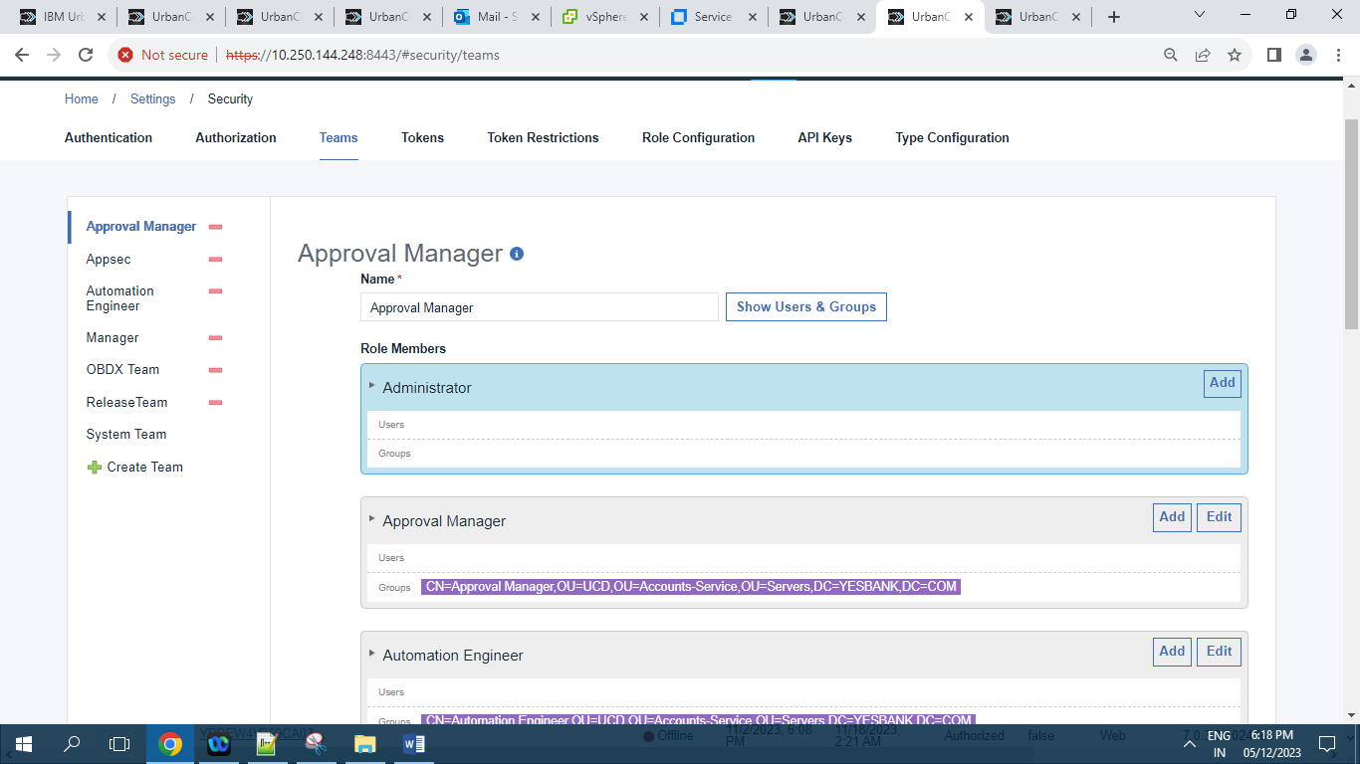

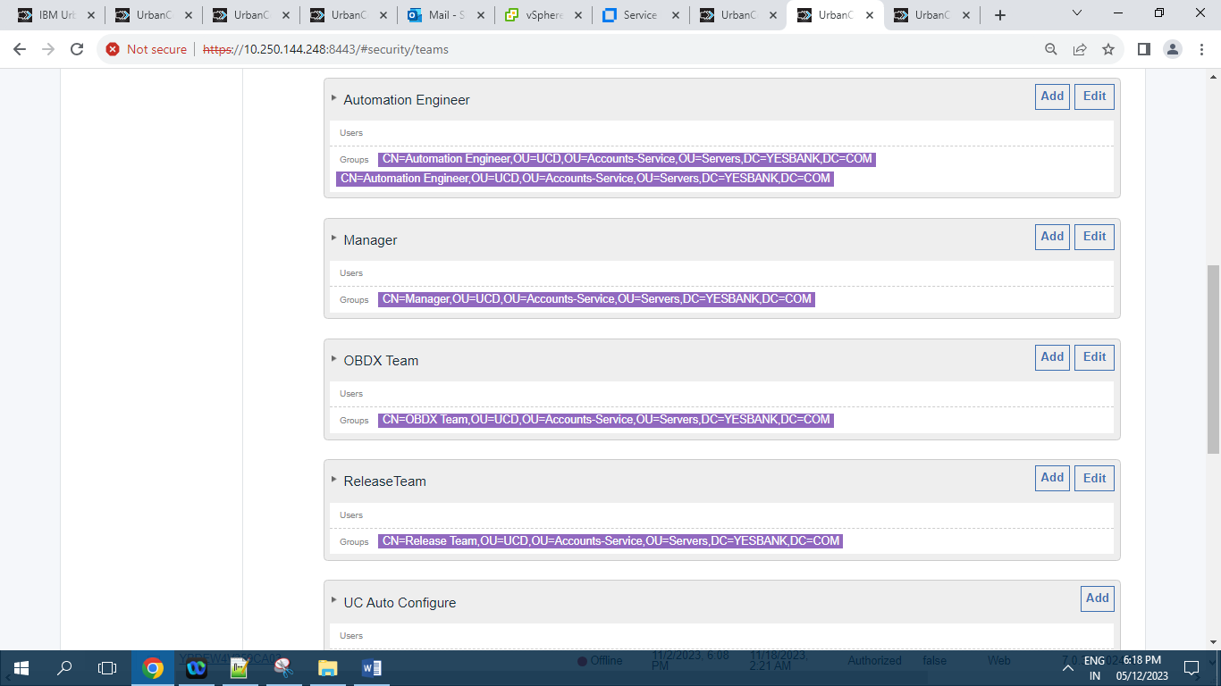

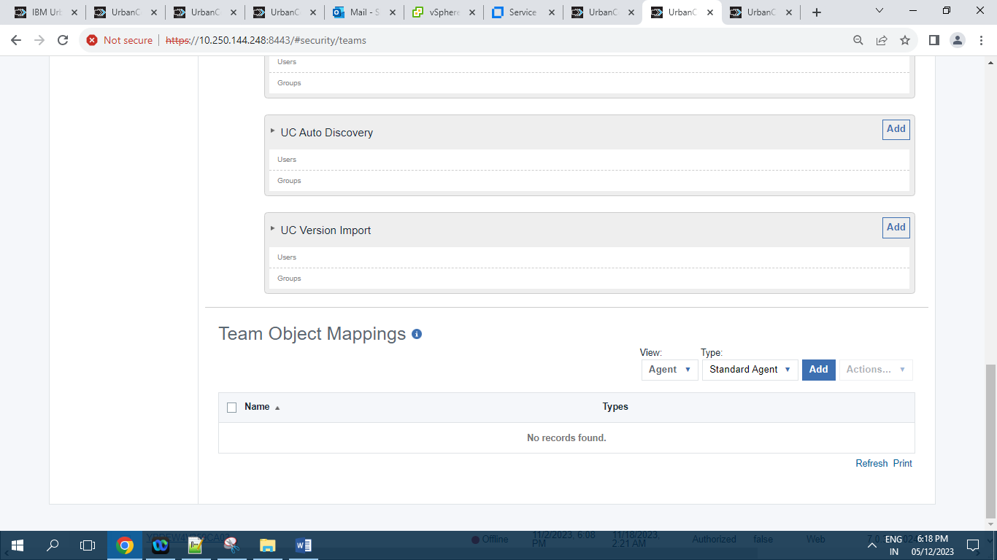

**10.2.4.2 ] Appsec :**

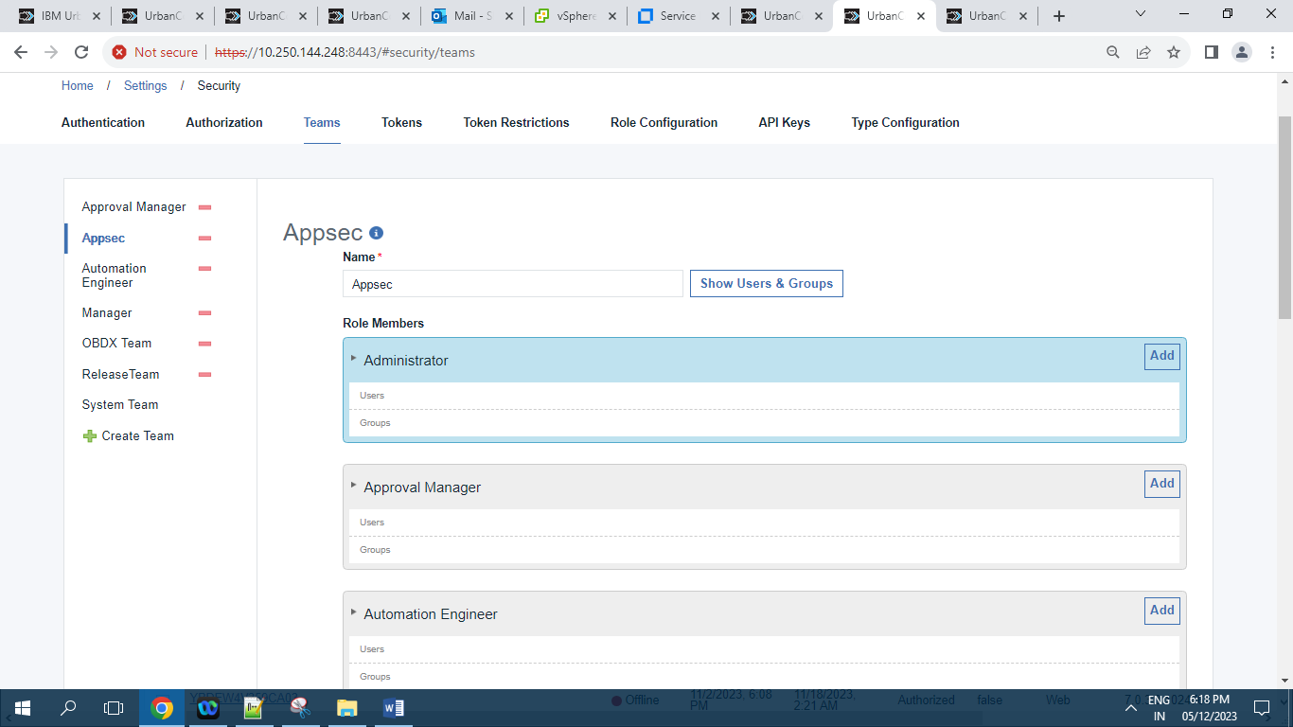

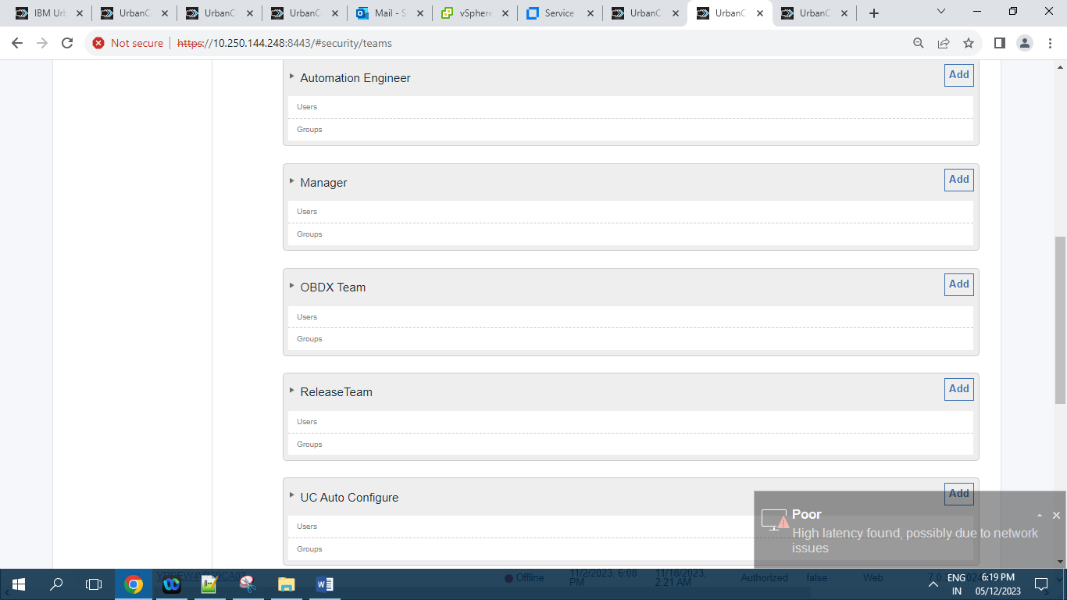

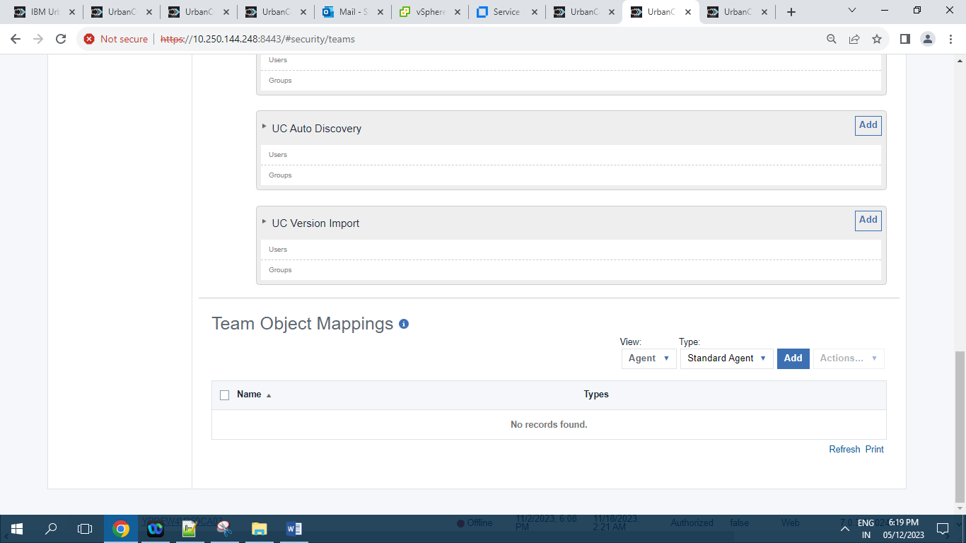

**10.2.4.3 ] Automation Engineer :**

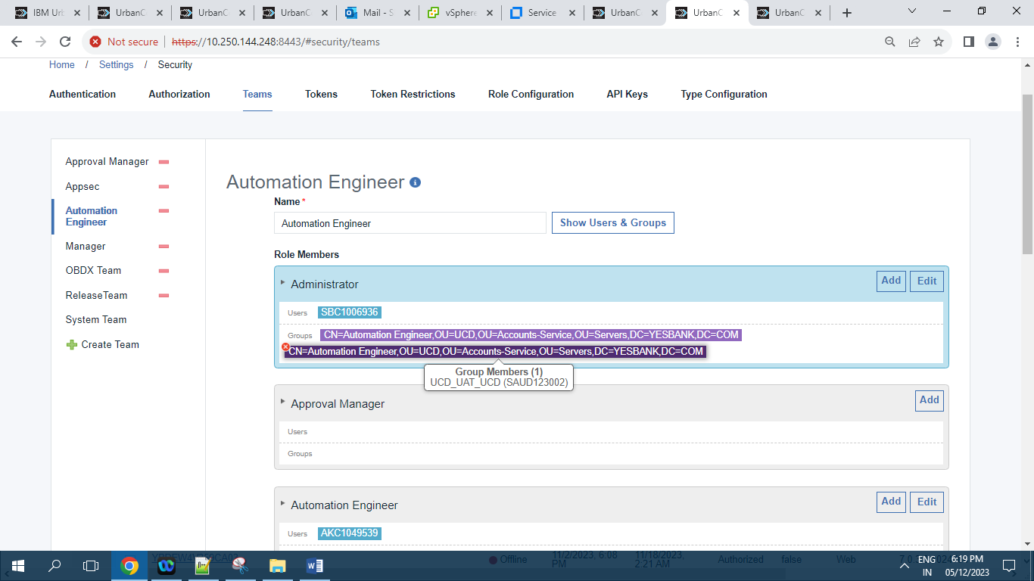

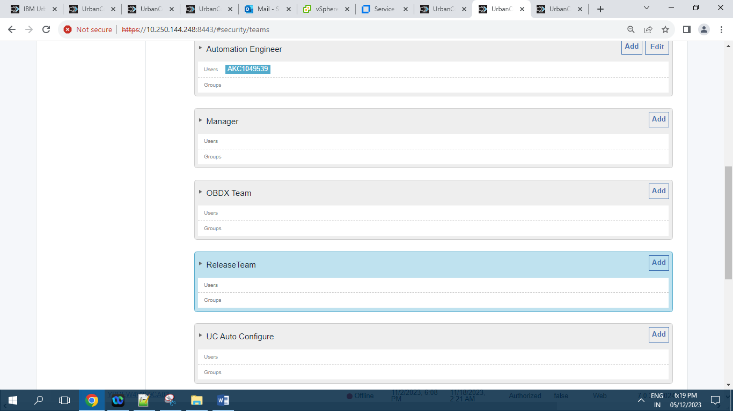

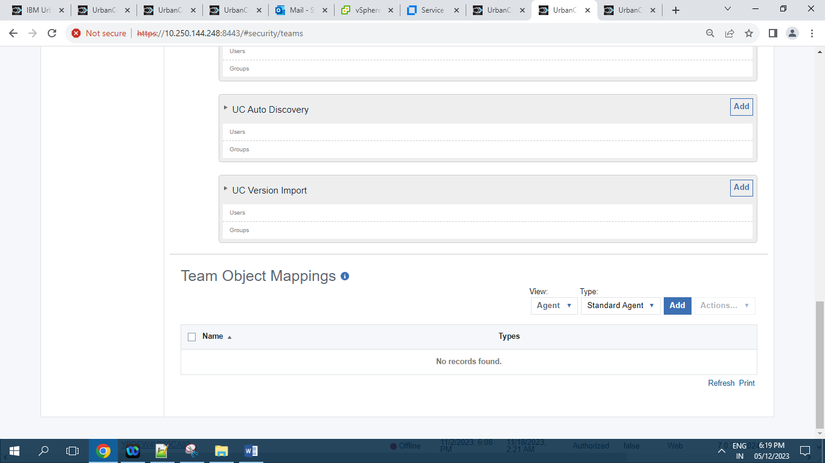

**10.2.4.4 ] Manager:**

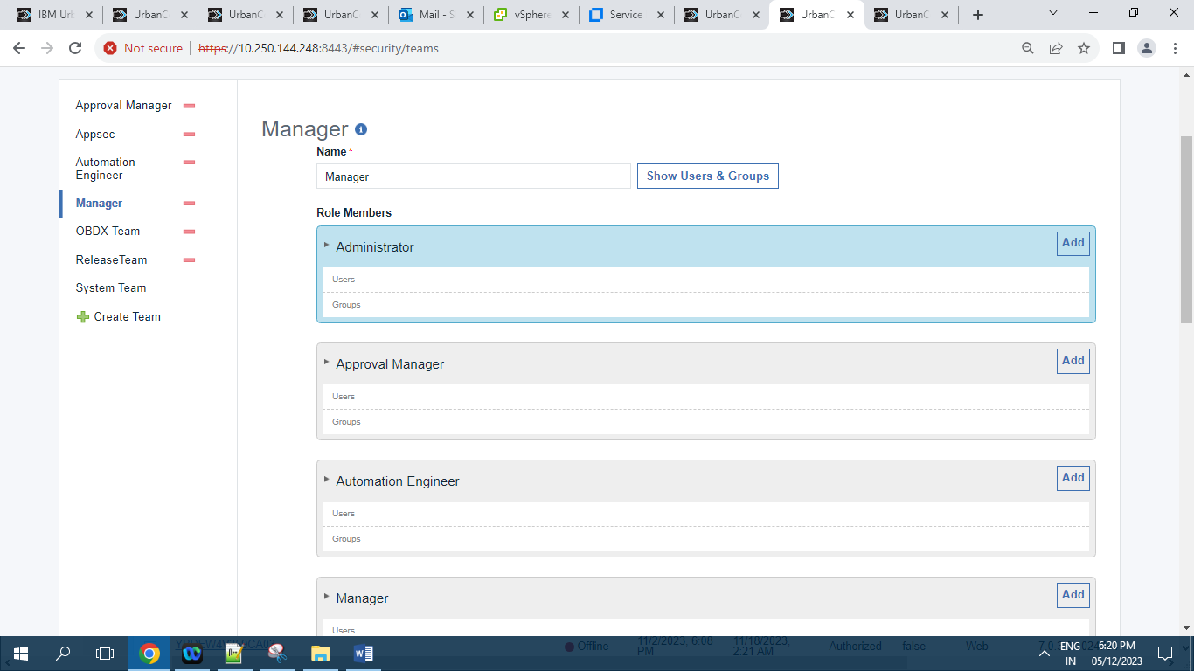

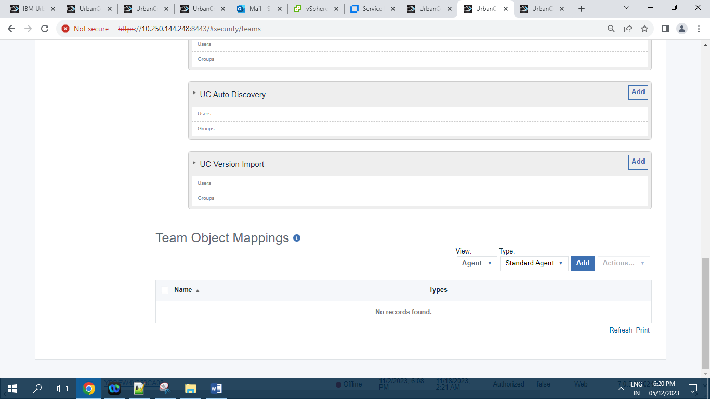

**10.2.4.5 ] OBDX Team :**

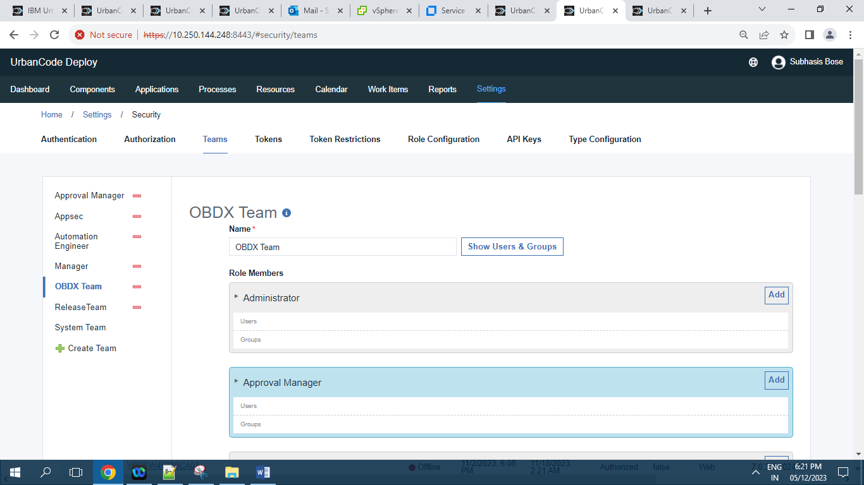

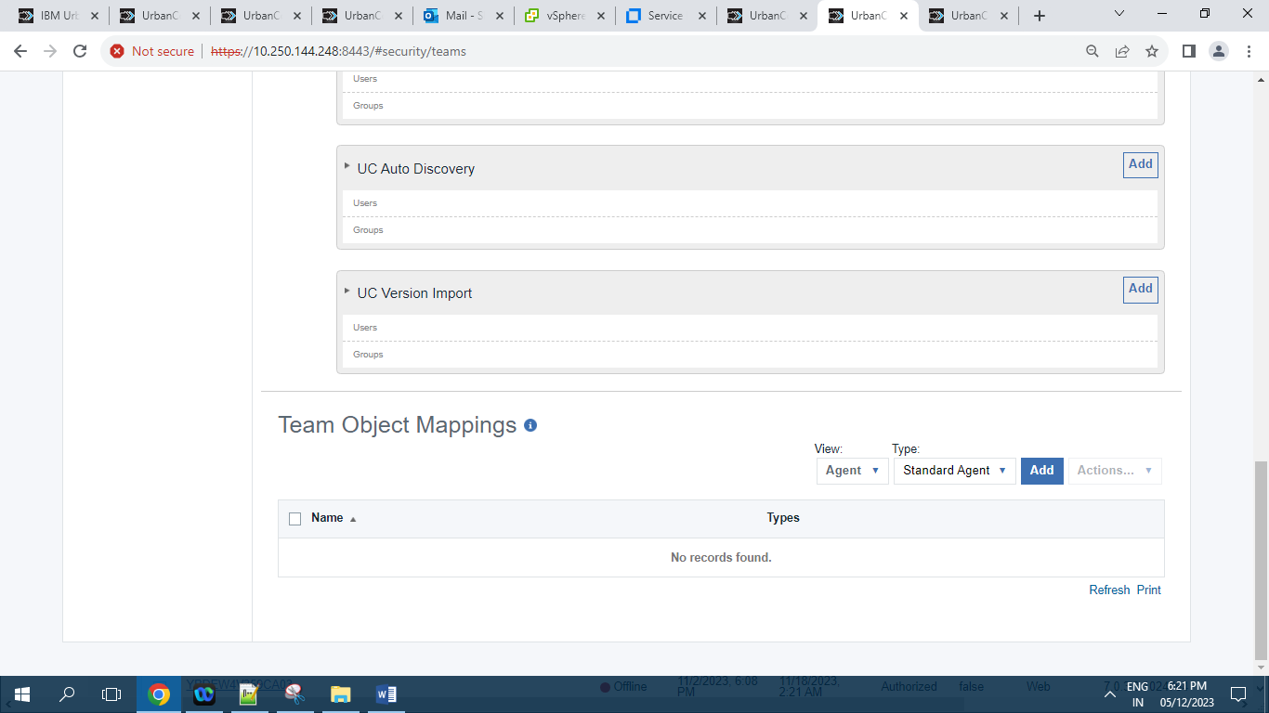

**10.2.4.6 ] Release Team :**

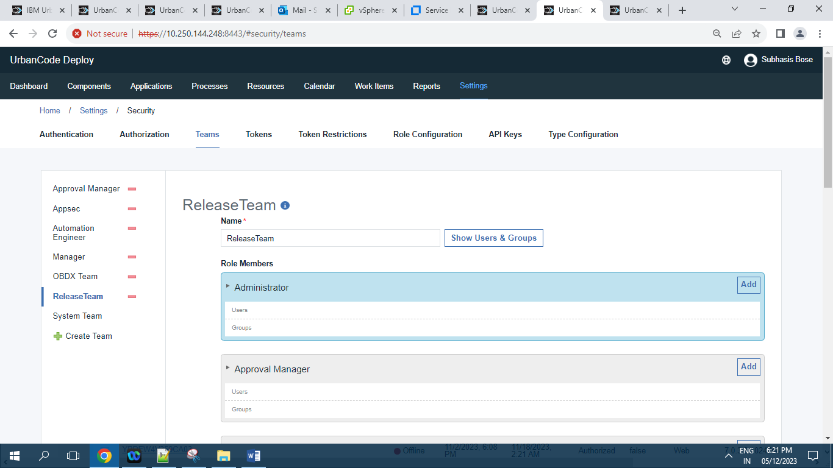



**10.2.4.7 ] System Team :**

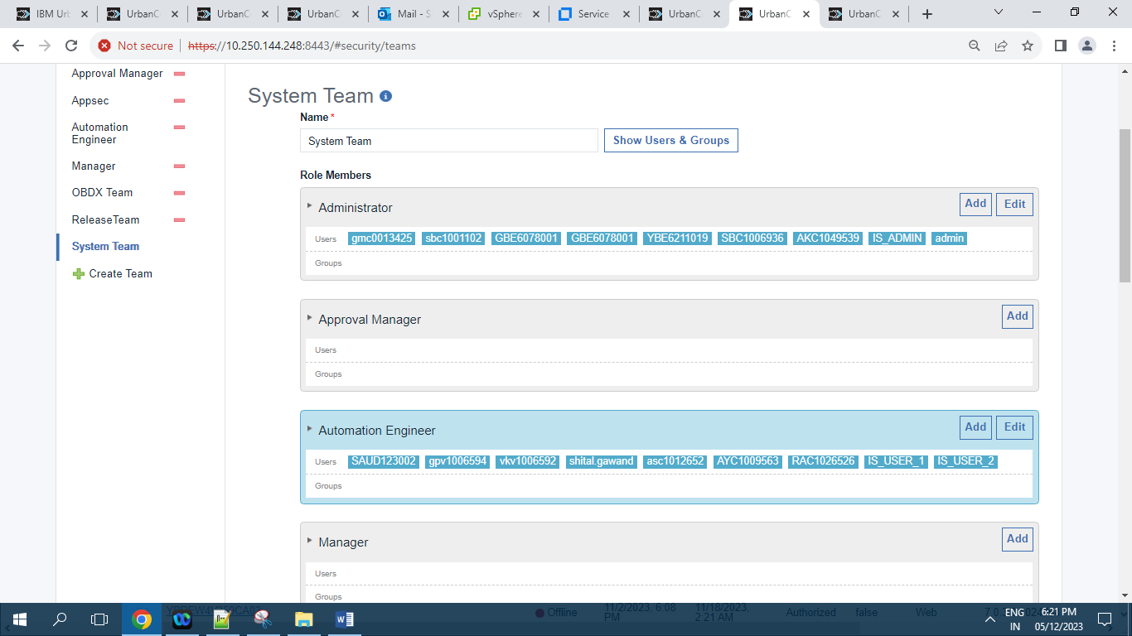

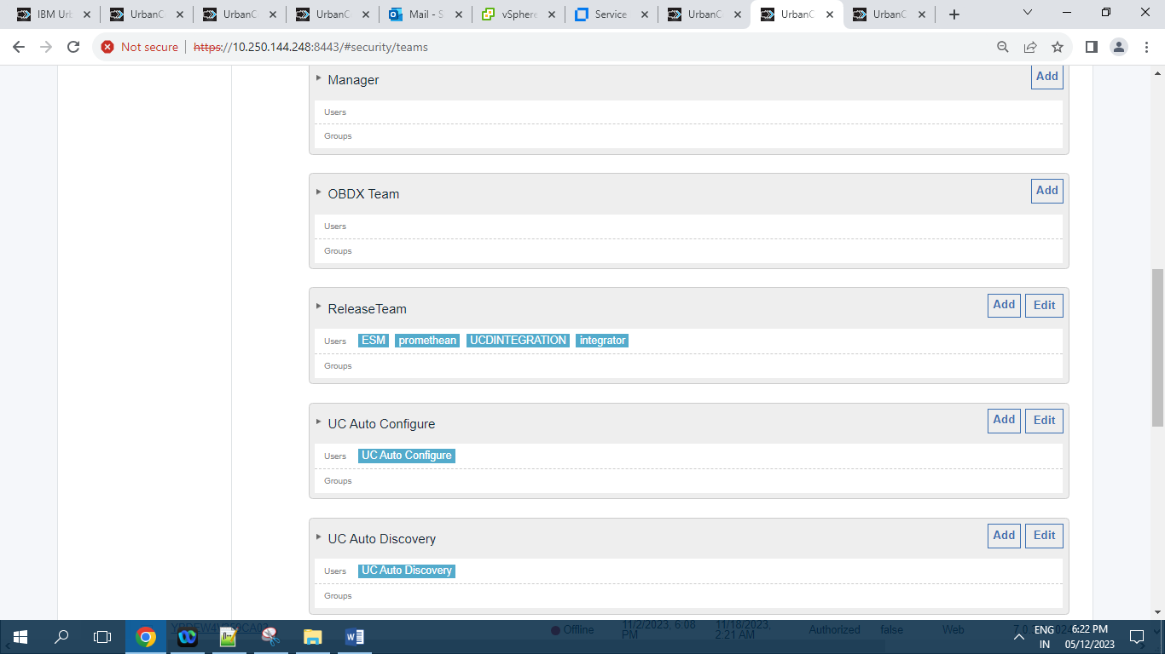

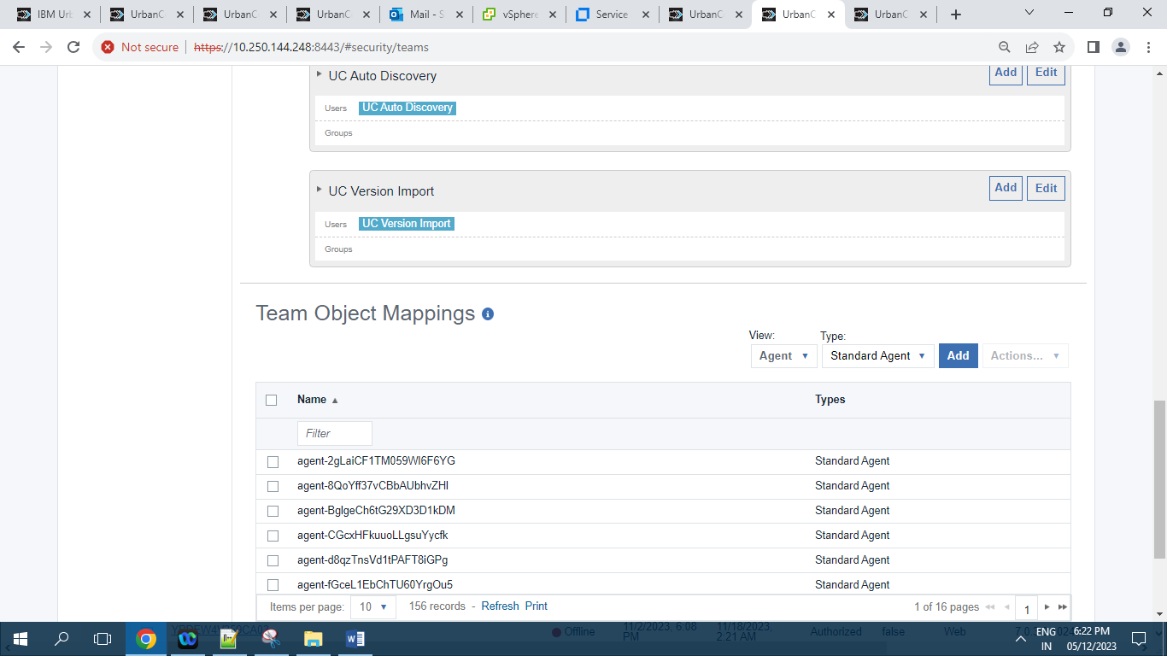

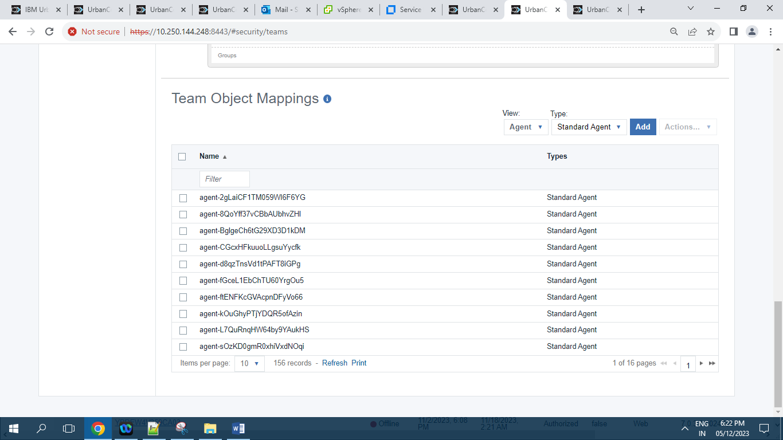

Records = 156

**10.2.5 ]** **Tokens :**

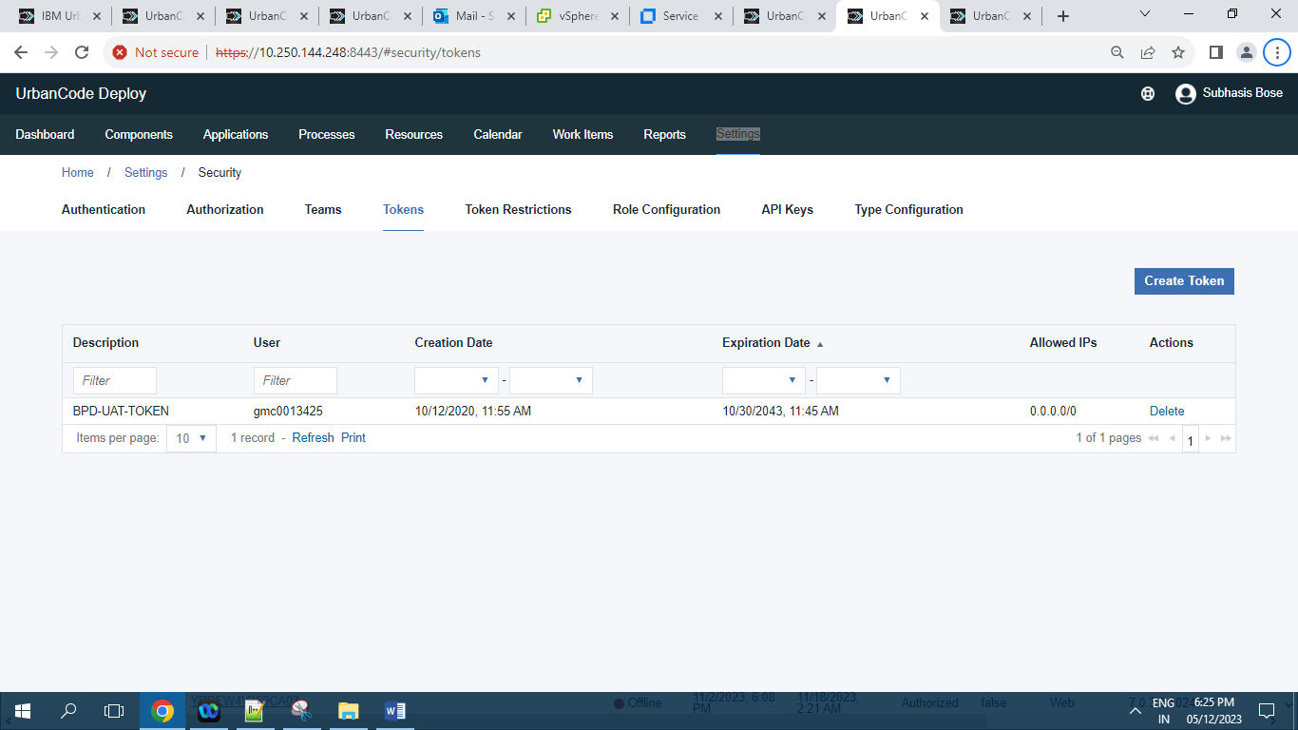

Screenshot of Tokens having 1 Record.

**10.2.6 ]** **Token Restrictions:**

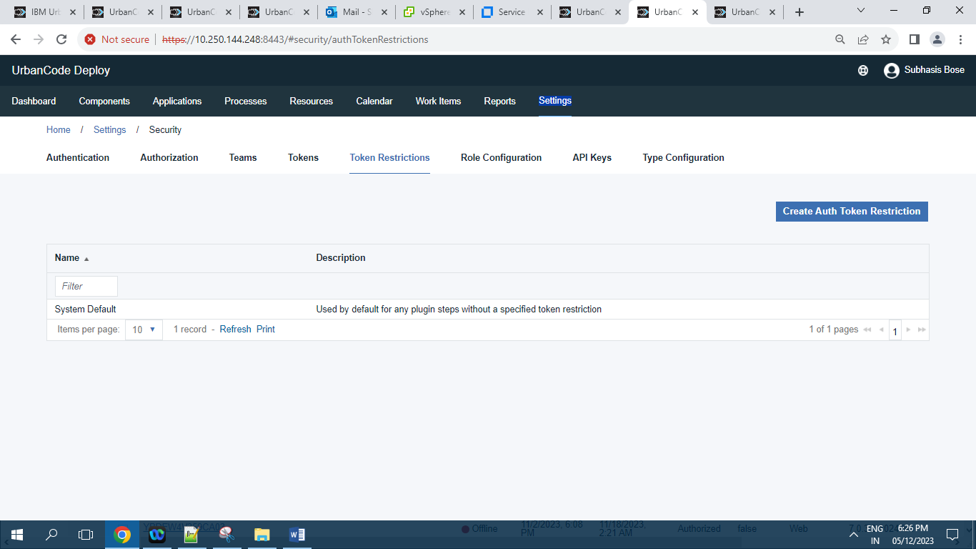

Screenshot of Token Restriction tab having 1 Record.

**10.2.7 ]** **Type Configuration :**

**10.2.7.1 ]** **Agent Types :**

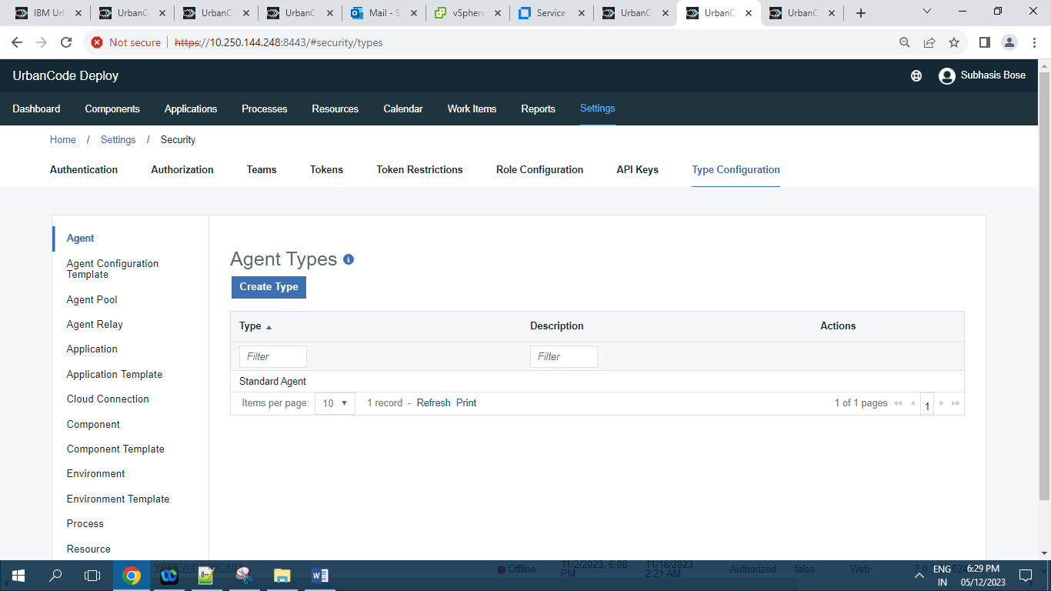

**10.2.7.2 ]** **Agent Configuration Template Types :**

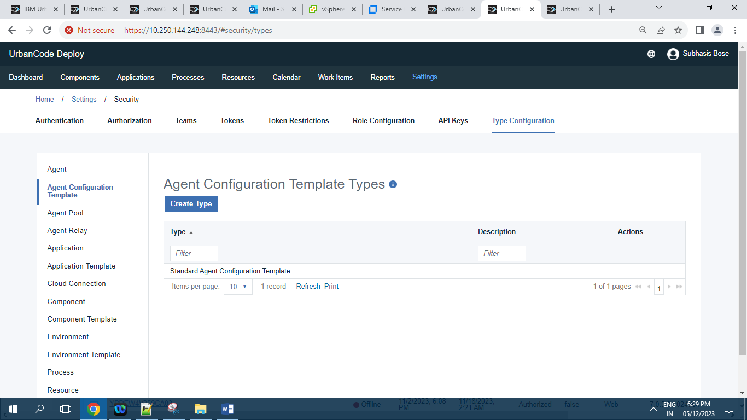

**10.2.7.3 ]** **Agent Pool Types :**

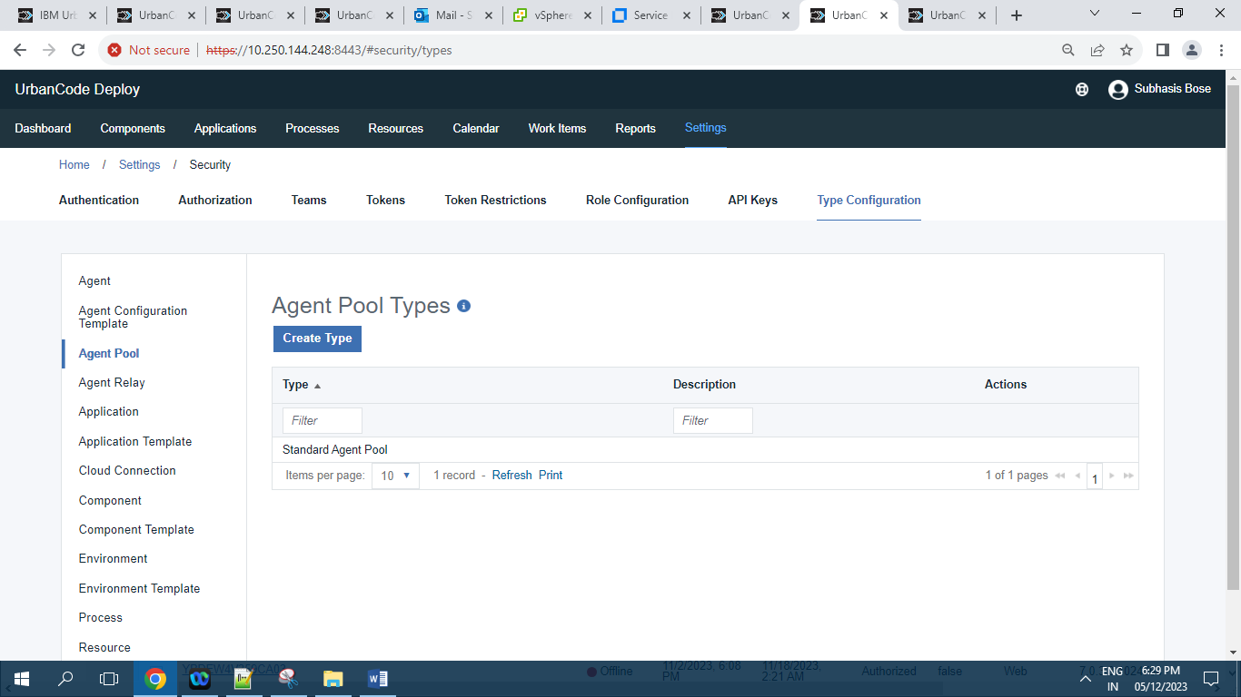

**10.2.7.4 ]** **Agent Relay Types :**

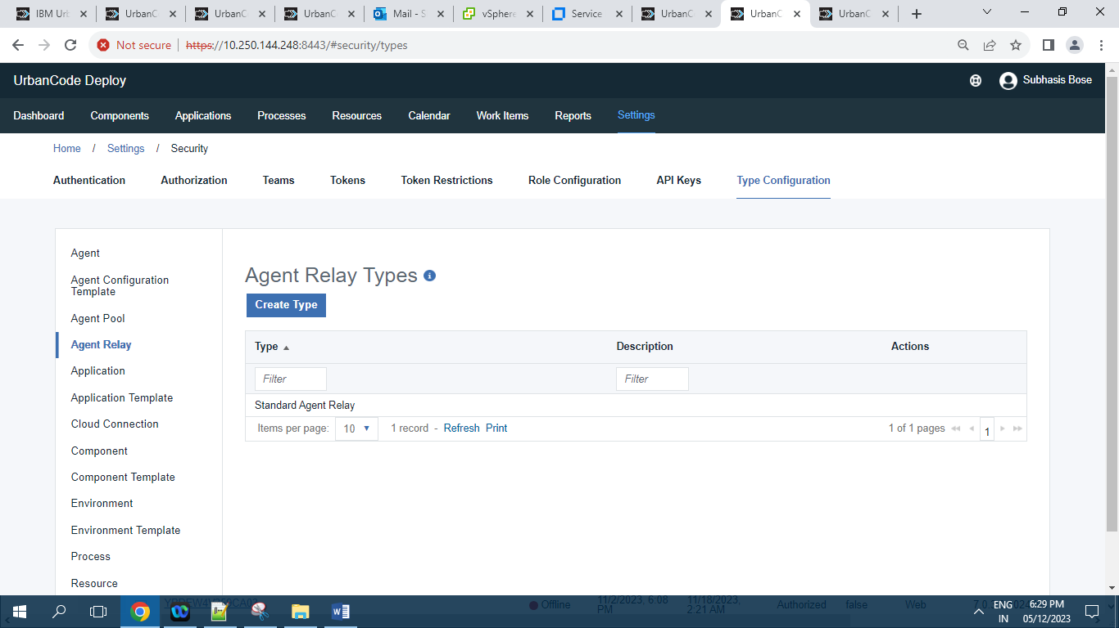

**10.2.7.5 ]** **Application Types :**

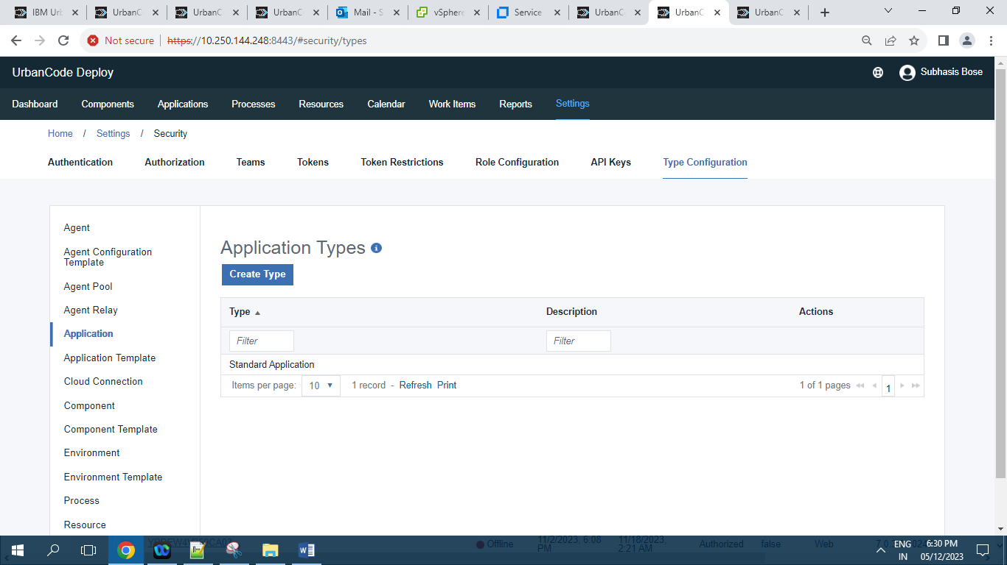

**10.2.7.6 ]** **Application Template Types :**

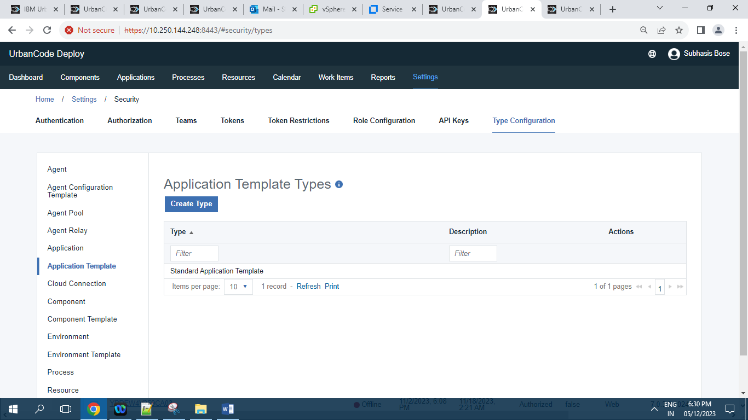

**10.2.7.7 ]** **Cloud Connection Types :**

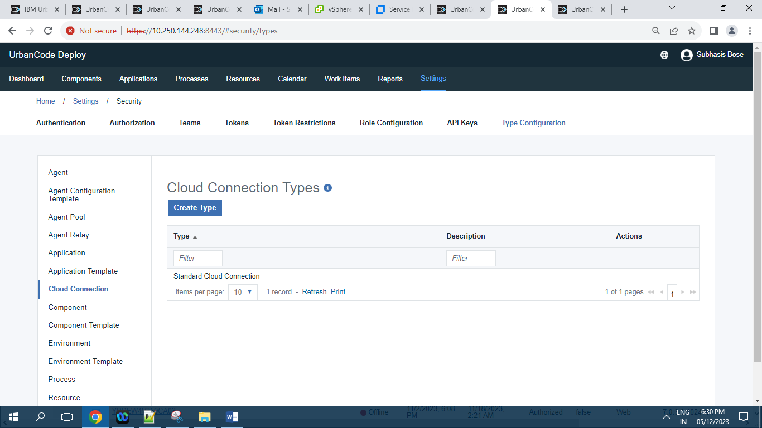

**10.2.7.8 ]** **Component Types :**

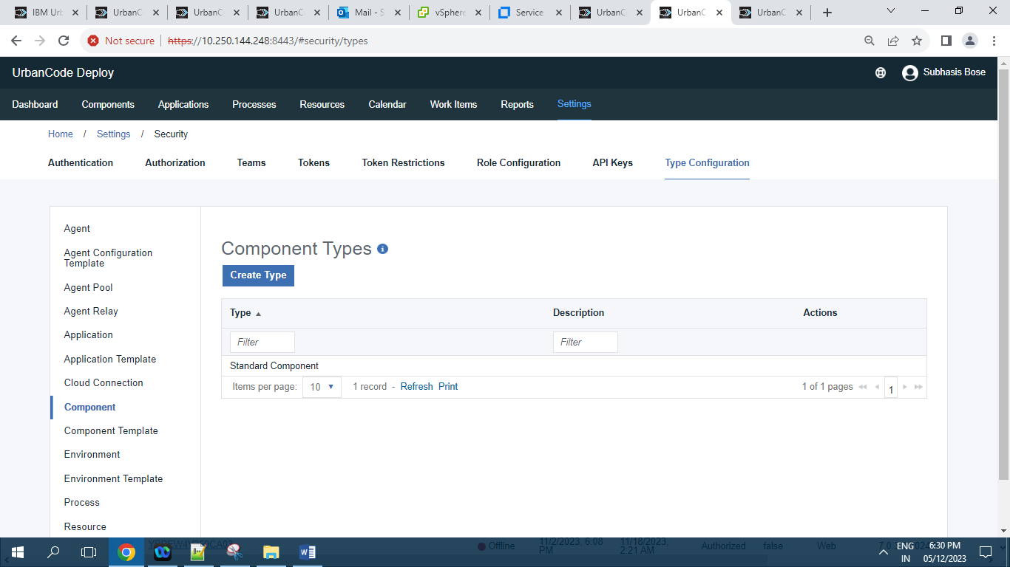

**10.2.7.9 ]** **Component Template Types :**

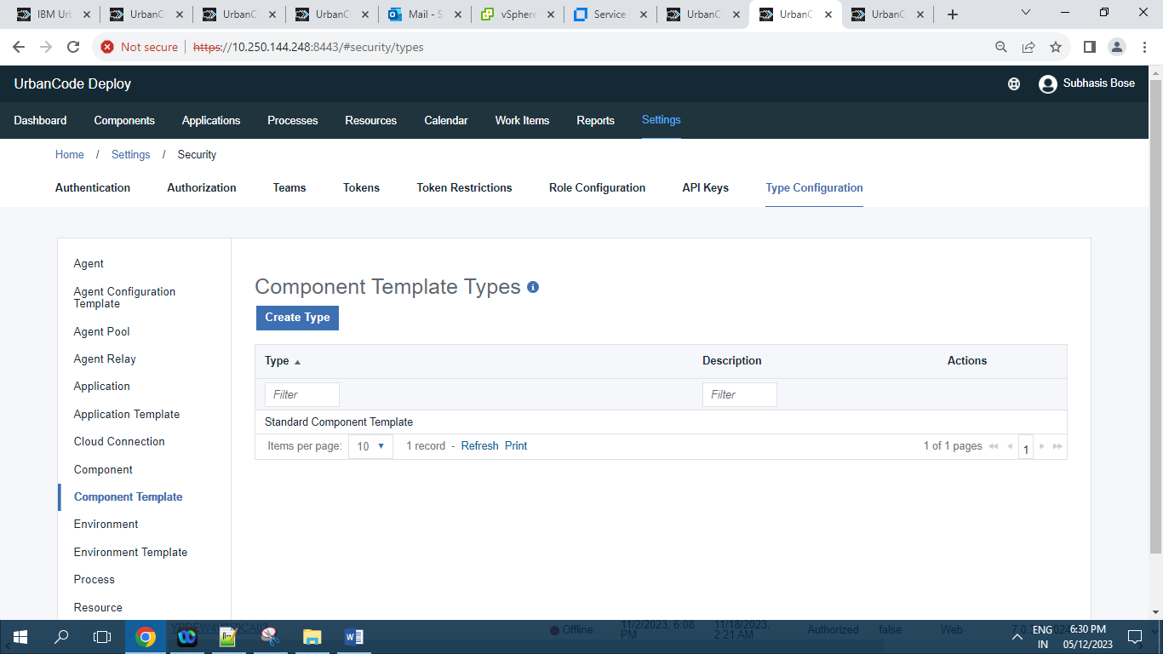

**10.2.7.10 ]** **Environment Types :**

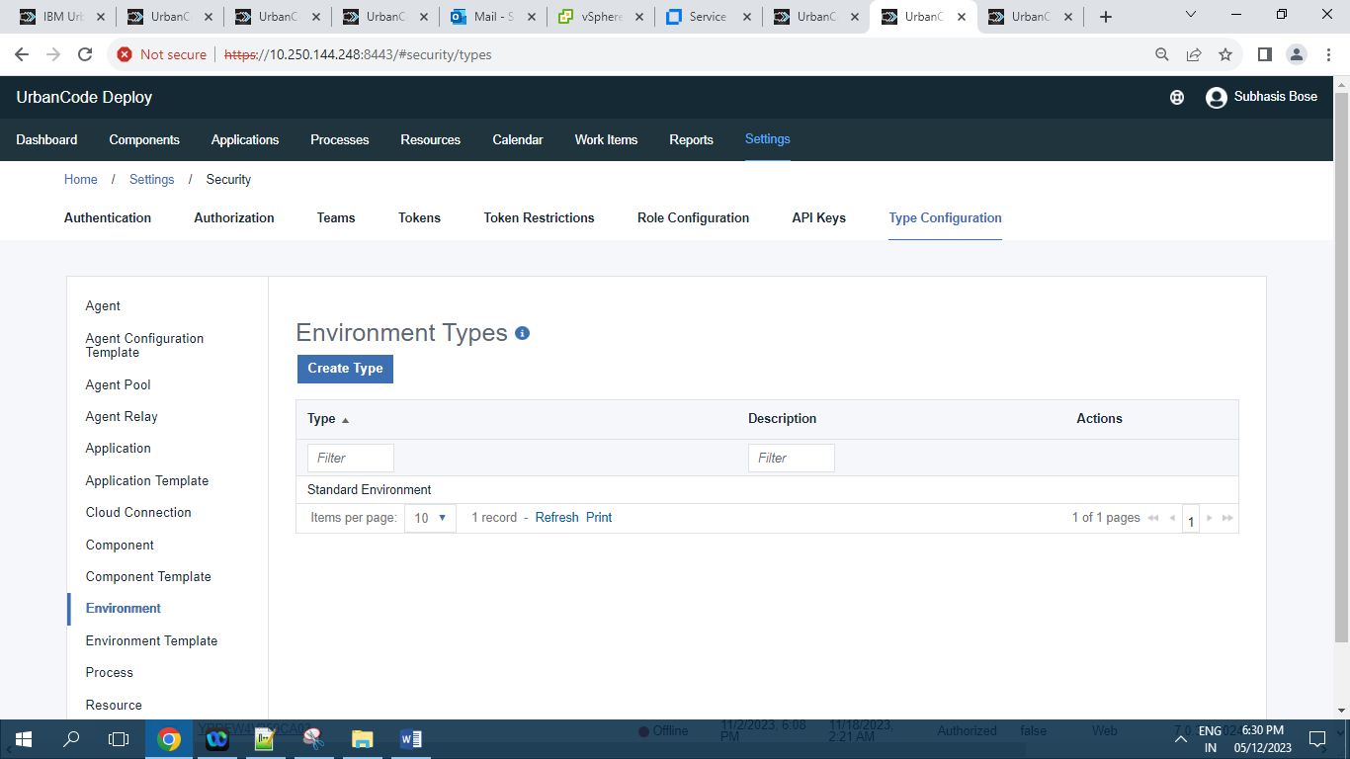

**10.2.7.11 ]** **Environment Template Types :**

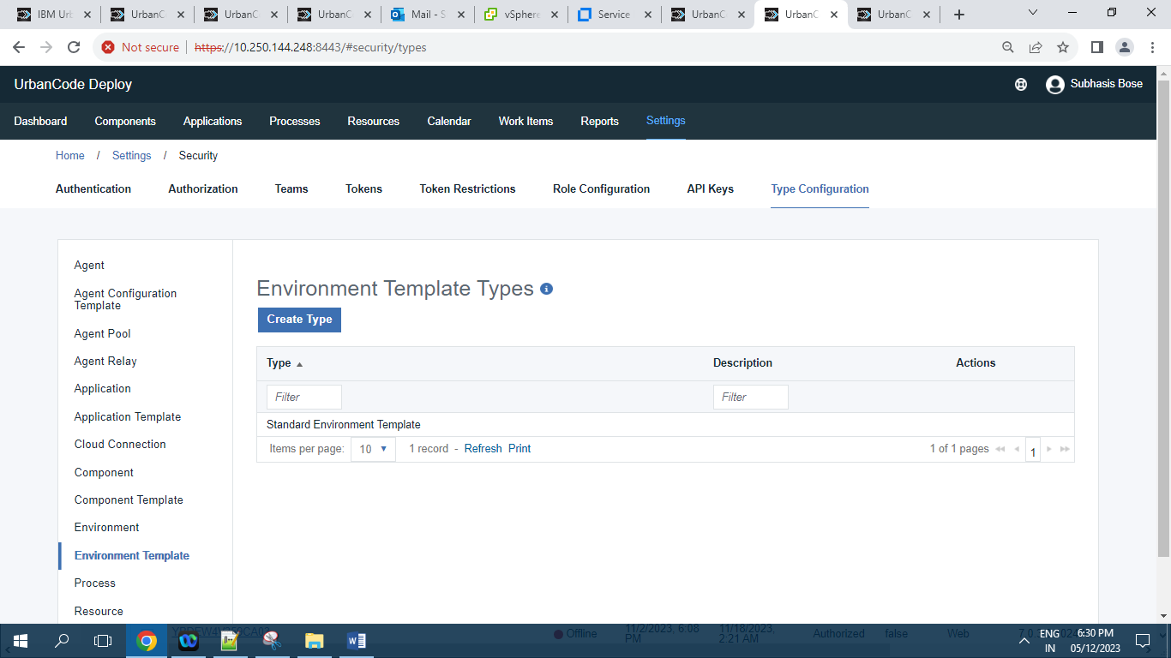

**10.2.7.12 ]** **Process Types :**

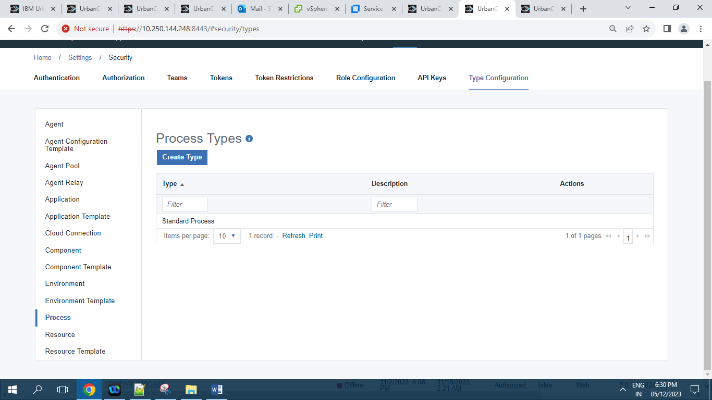

**10.2.7.13 ]** **Resource Types :**

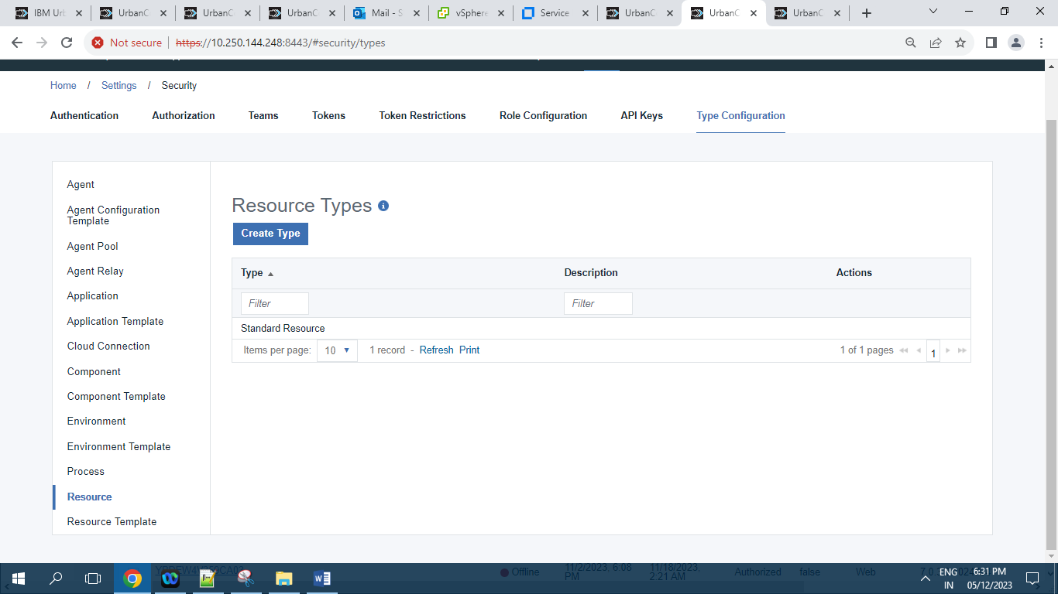

**10.2.7.14 ]** **Resource Template Types :**

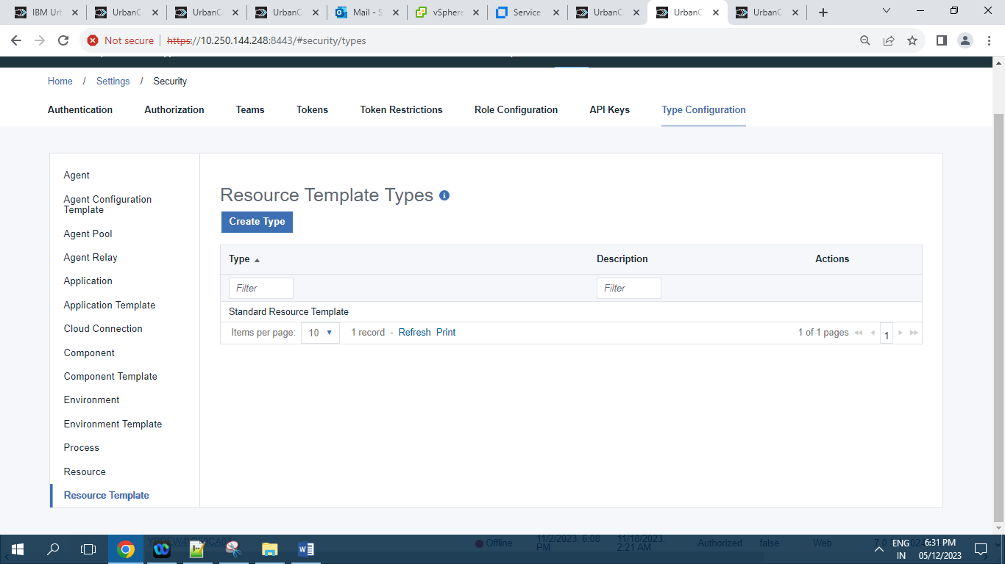

**10.2.8 ]** **Role Configuration:**

**10.2.8.1 ]** **Administrator:**

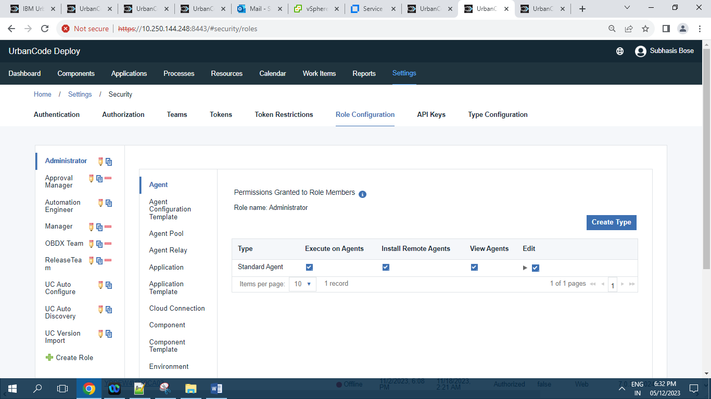

**10.2.8.2 ]** **Approval Manager:**

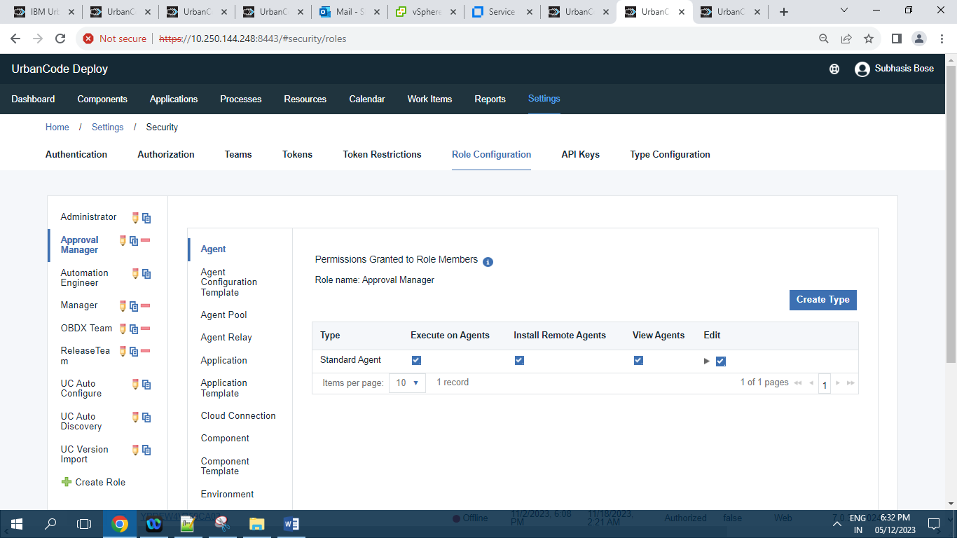

**10.2.8.3 ]** **Automation Engineer:**

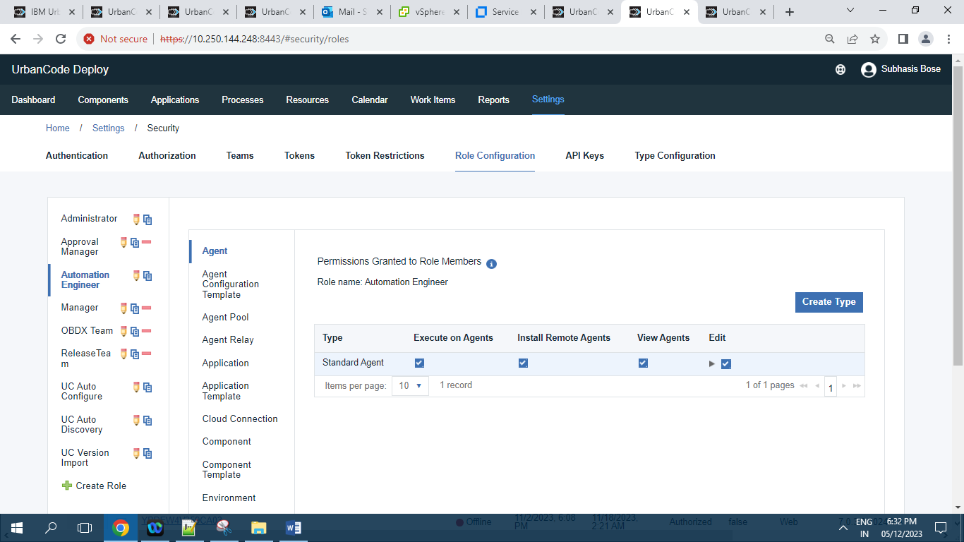

**10.2.8.4 ]** **Manager:**

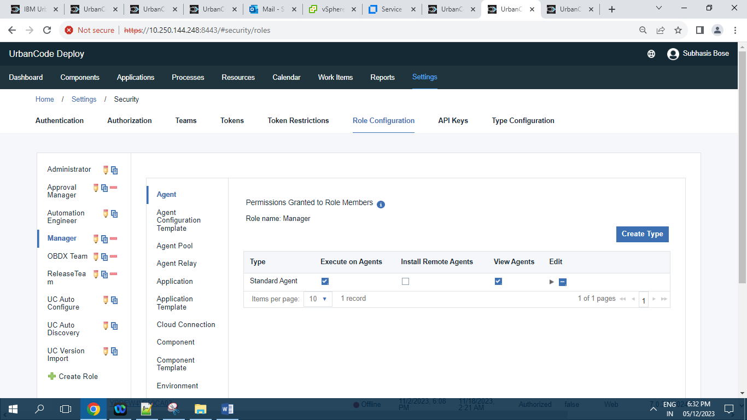

**10.2.8.5 ]** **OBDX Team :**

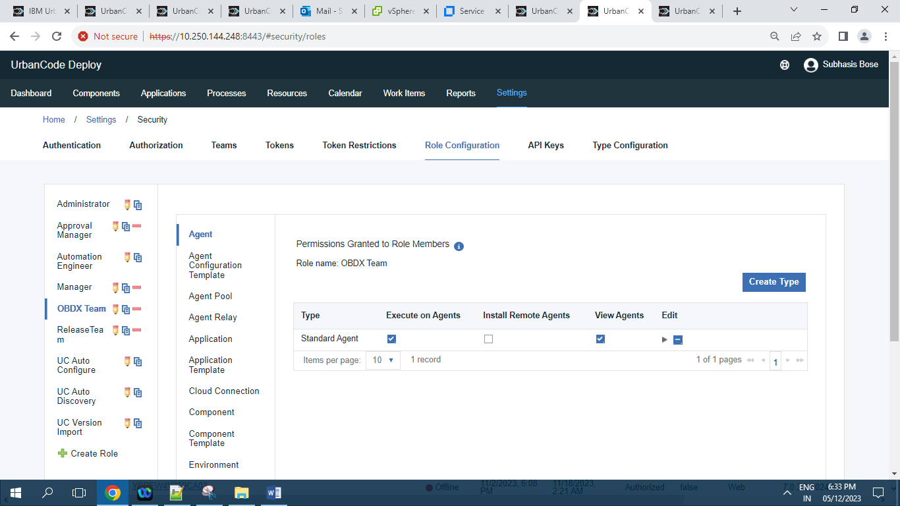

**10.2.8.6 ]** **Release Team :**

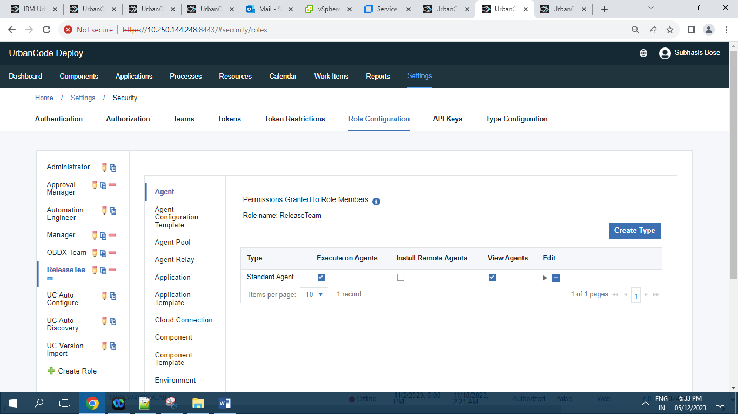

**10.2.8.7 ]** **UC Auto Configure:**

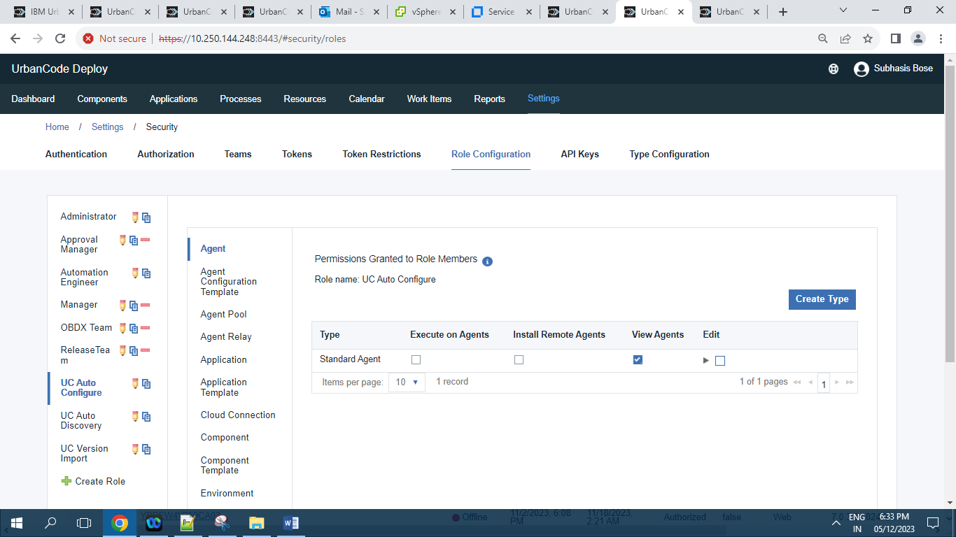

**10.2.8.8 ]** **UC Auto Discovery:**

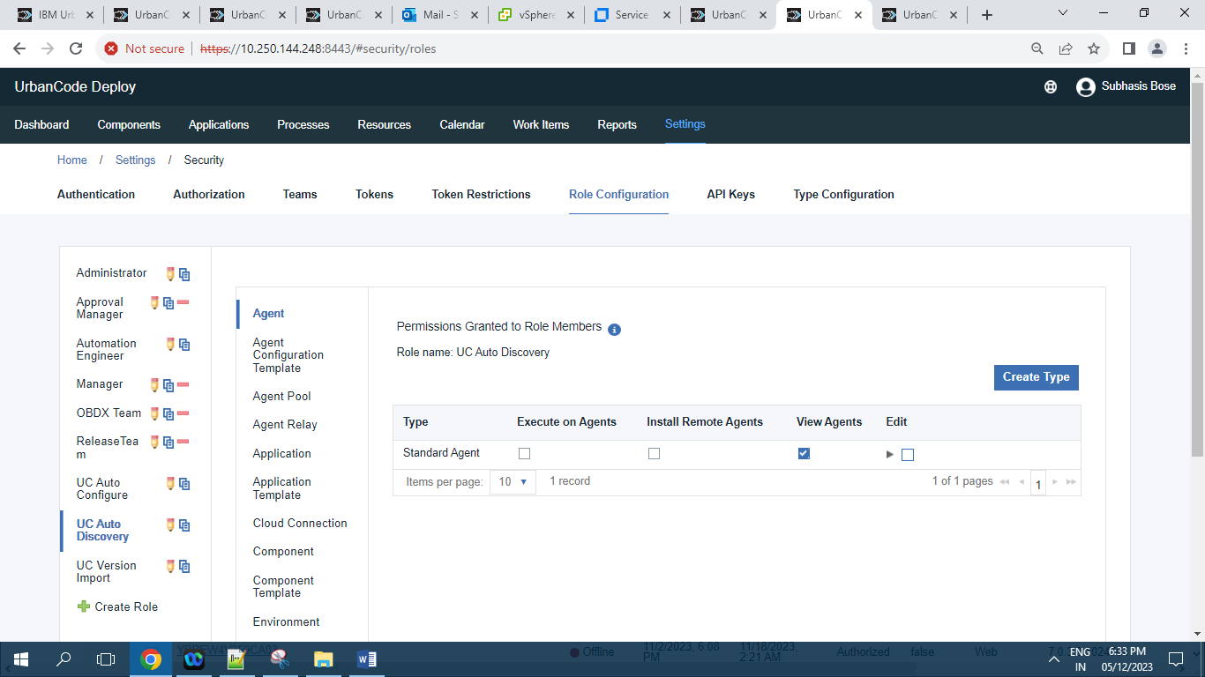

**10.2.8.9 ]** **UC Version Import :**

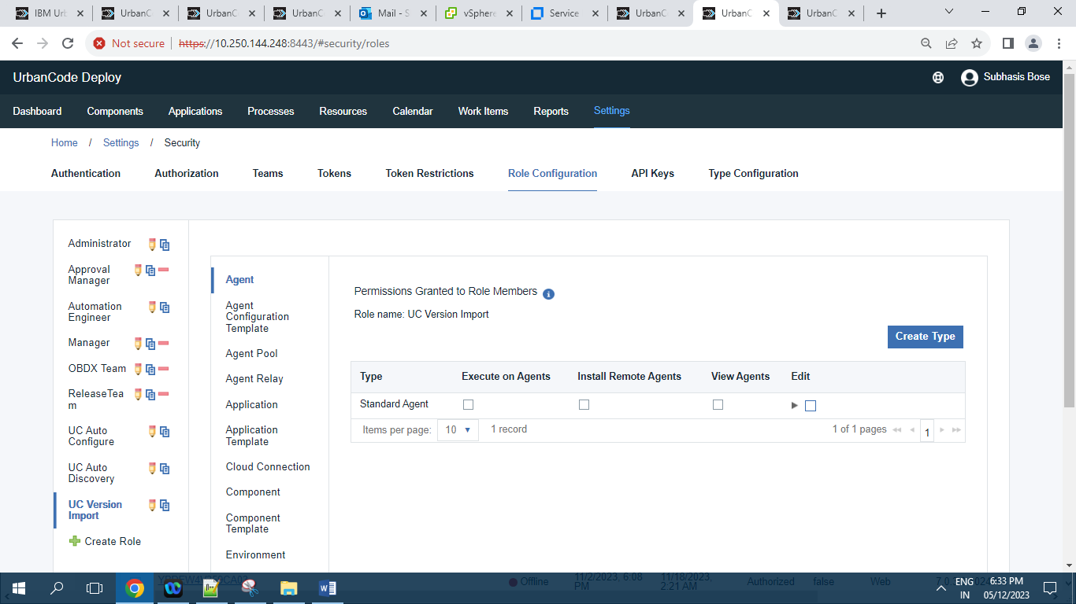

**10.3 ]** **System:**

**10.3.1 ]** **Logging :**

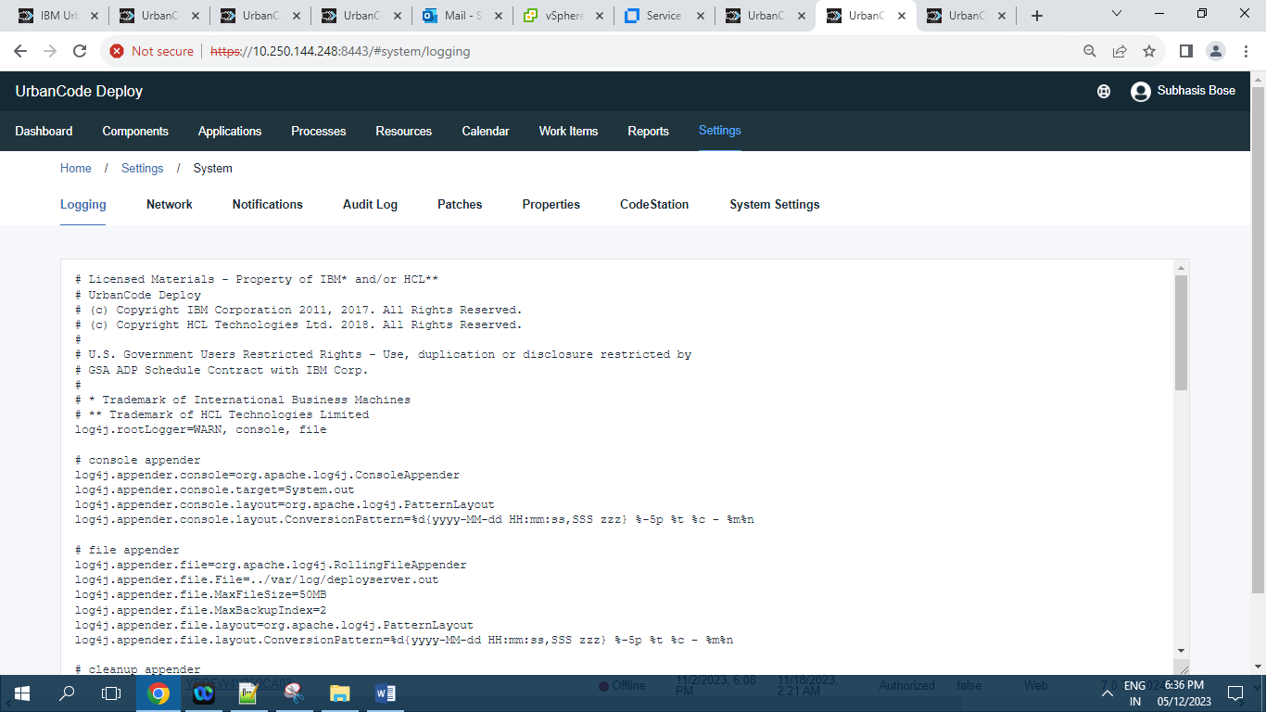

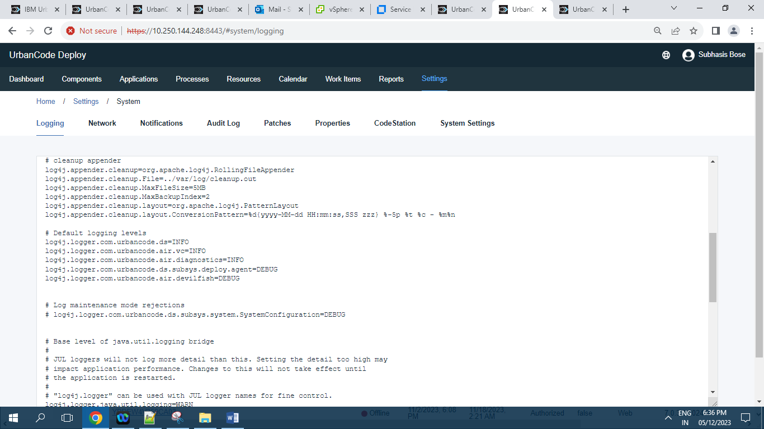

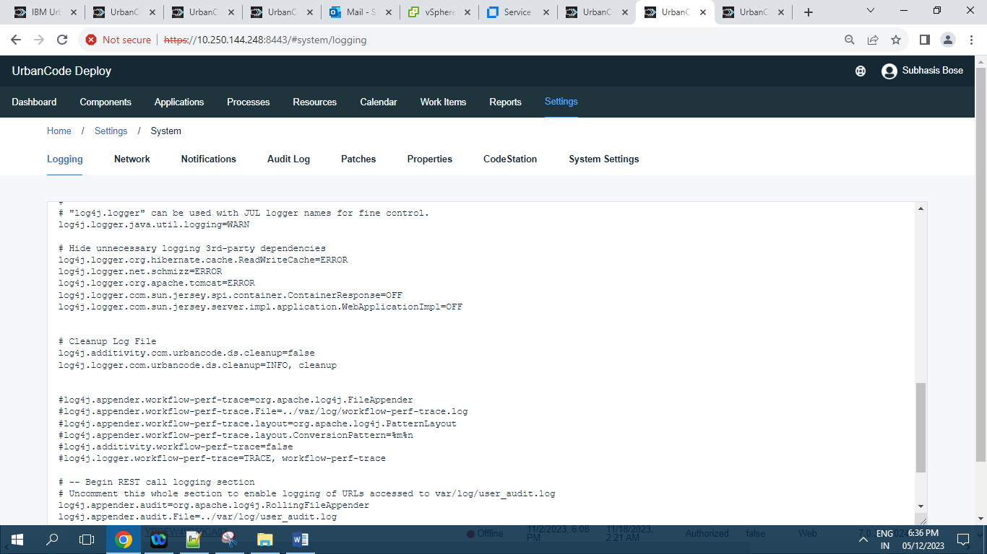

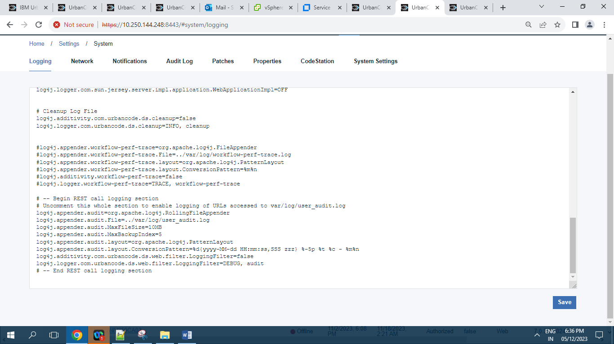

**10.3.2 ]** **Network :**

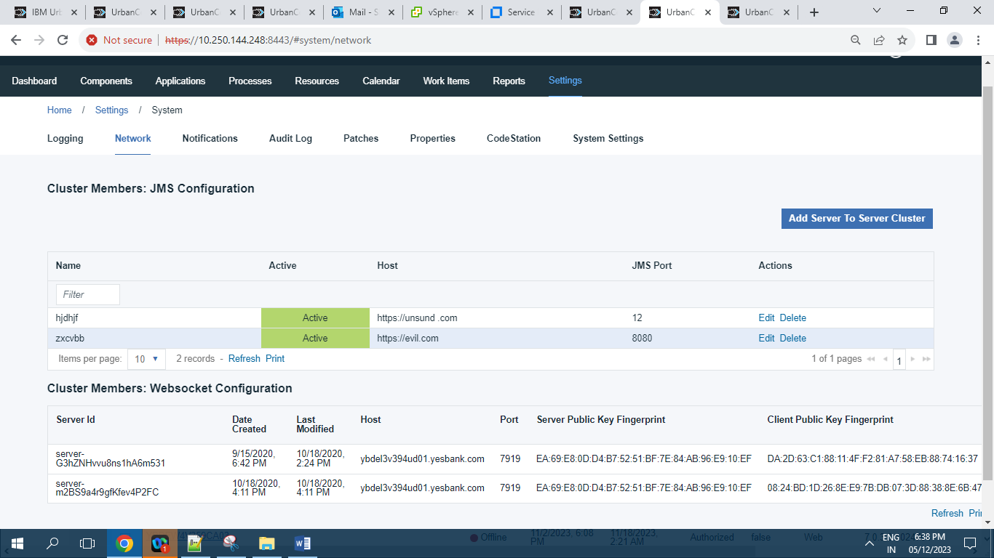

**10.3.3 ]** **Notification Schemes :**

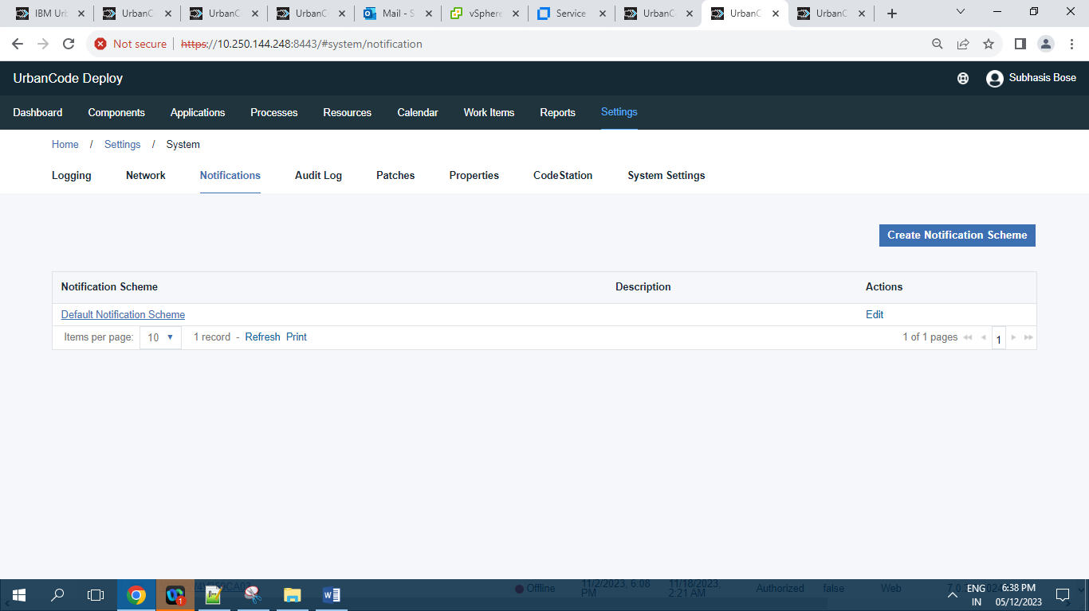

Record = 1

**10.3.4 ]** **Audit Log :**

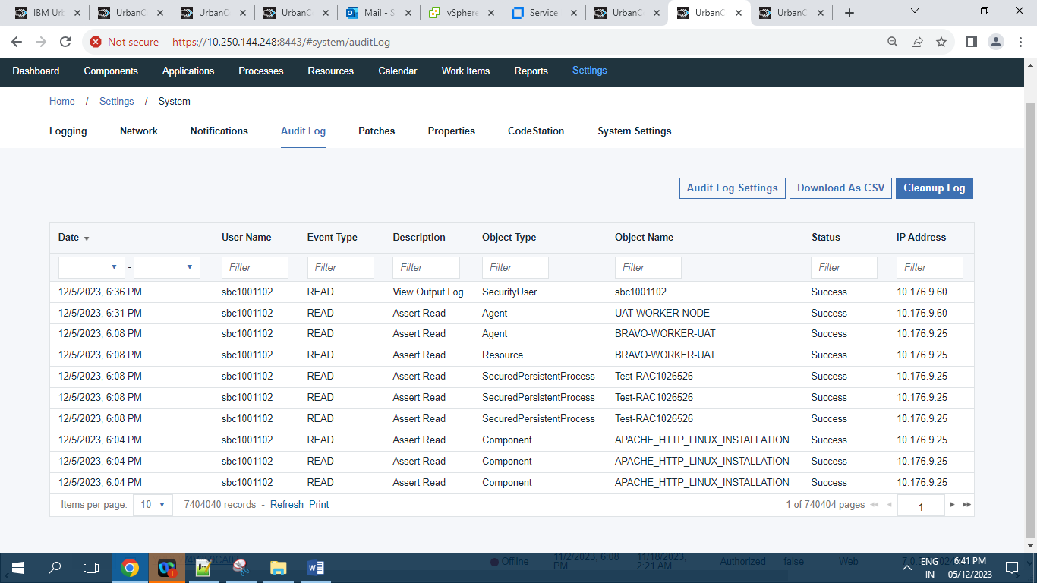

Records = 7404040

**10.3.5 ]** **Patches :**

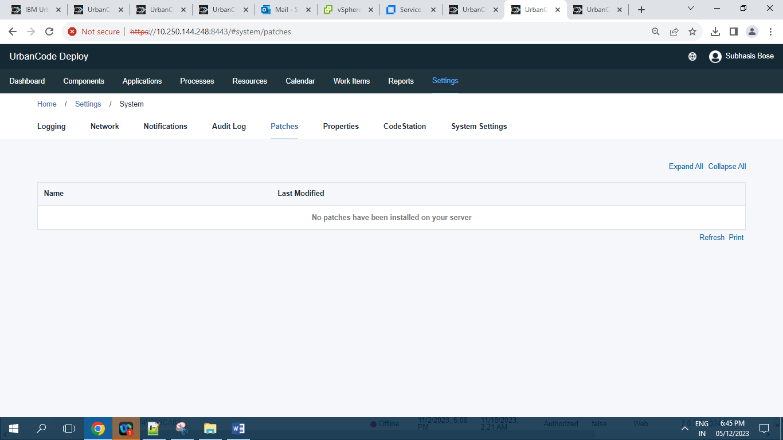

Record = 0

**10.3.6 ]** **Properties**

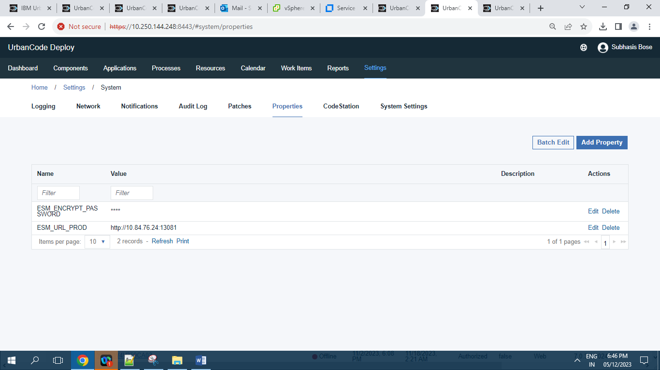

Records =2

**10.3.7 ]** **CodeStation :**

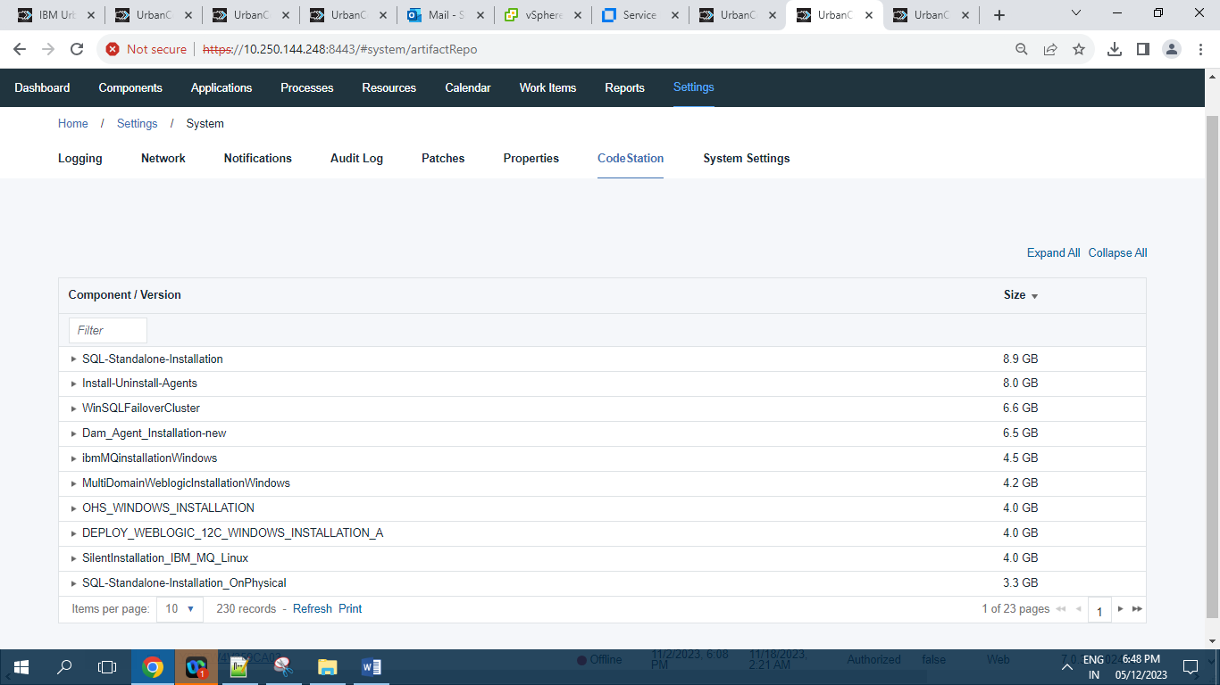

Records = 230

**10.3.8 ]** **Diagnostics:**

**10.3.8.1 ]** **Java Thread Dumps**

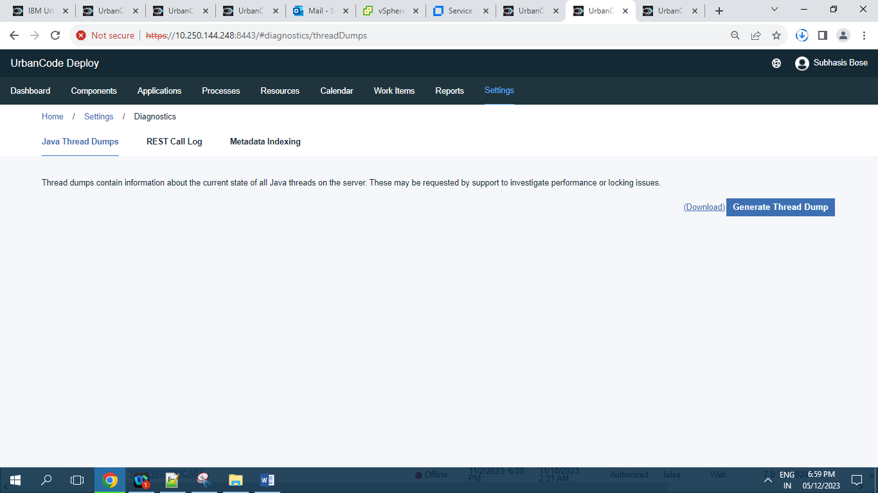

**10.3.8.2 ]** **REST Call Log:**

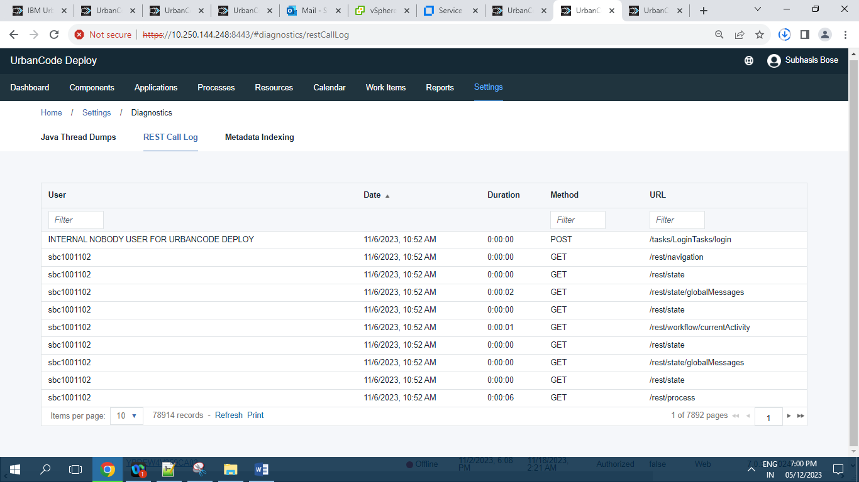

Records = 78914

**10.3.8.3 ]** **Metadata Indexing :**

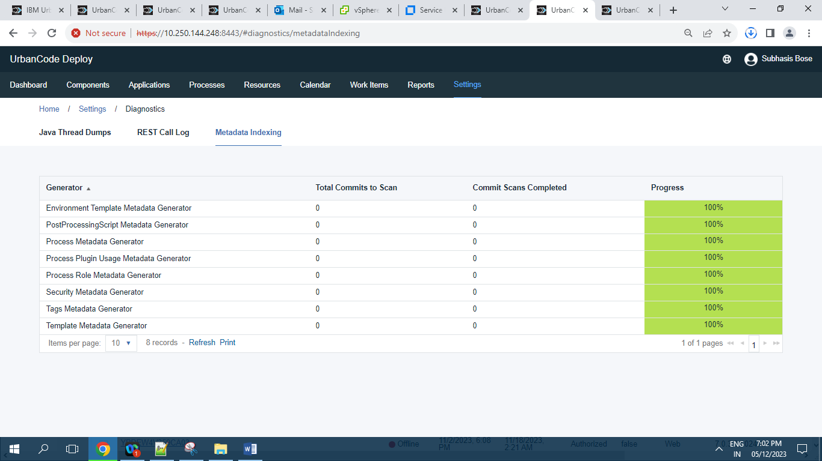

Records = 8 records

**10.3.9 ]** **System Settings:**

